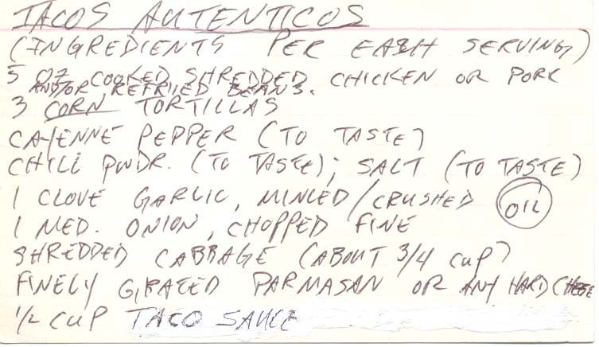
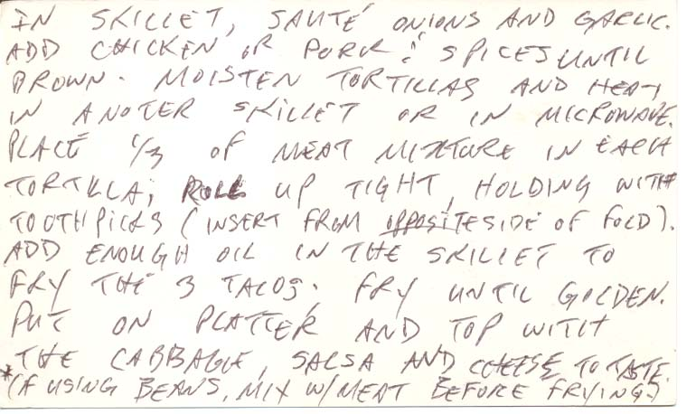
NOTE: If you use flour tortillas and fold the ends before frying, you have chimichangas!

