Taco Soup (recipe makes 8 servings)

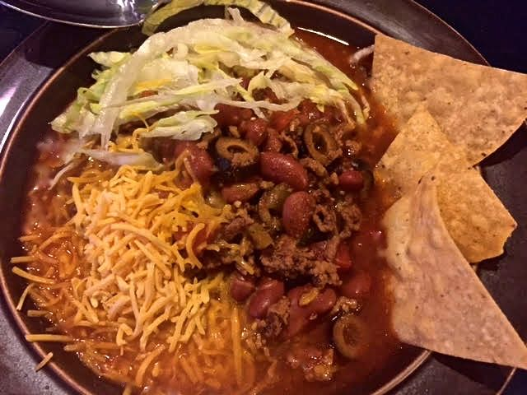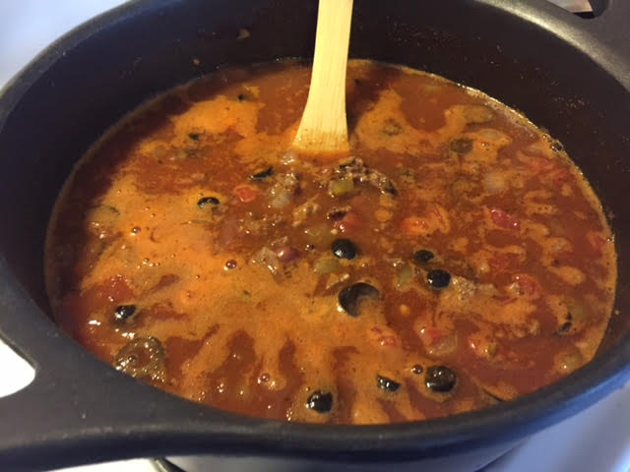

This is my take off the typical recipe for “Taco Soup” (I add the garnishes to mine).

Ingredients:
1 pound lean ground beef
1 cup chopped onion
4 cloves garlic, finely minced
1, 16-ounce can chili beans and liquid
1, 15-ounce can light kidney beans, drained
1, 8-ounce can tomato sauce
2 cups water
1, 14.5-ounce can petite-diced tomatoes
1, 4-ounce can chopped green chilies
1, 2.25-ounce can sliced black olives
3 tablespoons Frank’s “Red Hot” sauce
⅛ teaspoon ground cumin
2 teaspoons onion powder
2 teaspoons garlic powder
½ teaspoon ground cayenne
1 tablespoon dark chili powder
½ teaspoon table salt
½ teaspoon ground, black pepper
Shredded iceberg lettuce, shredded Cheddar cheese, tortilla chips (for garnish)

Preparation:
Brown the beef in a Dutch oven or other large pot with the onion and garlic, seasoned with a sprinkling of salt and pepper. Add all the rest of the ingredients (except the lettuce, cheese and tortilla chips garnishes), bring to a boil, then lower the heat until it’s just simmering, cover the pot and let simmer gently for 1 hour. Garnish with shredded lettuce, shredded cheese and tortilla chips.

