TOSTONES (crispy, fried plantain chips)

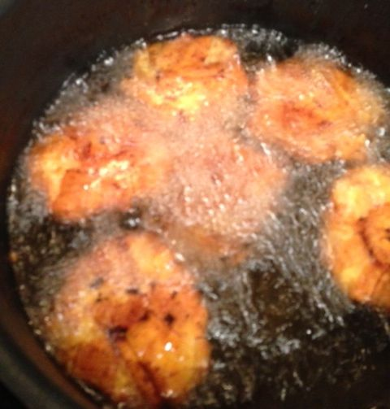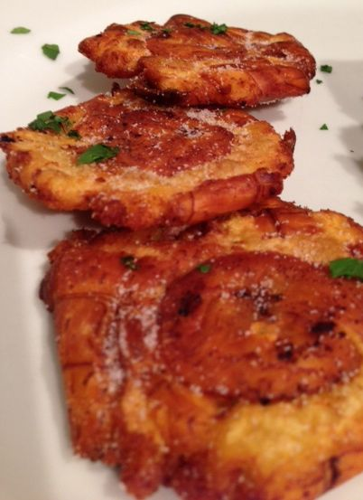

These are popular as a side dish in Spanish-speaking, Caribbean lands, like Puerto Rico, Cuba and the Dominican Republic.

ingredients:
1 large unripe (green) or barely ripe (slightly yellow) plantain per two servings (a nice-sized plantain should render about six pieces, so there are 3 pieces per serving)
a small amount of chopped cilantro, for garnish
oil for frying
salt

preparation:
With a small, sharp knife, cut ends from each plantain and cut a lengthwise slit through skin. Stick your fingers underneath the slit skin to pry it off the plantain. Cut plantains crosswise into 1-inch-thick pieces.

In a 12-inch skillet or large, deep saucepan, heat ½ inch oil over moderate heat until just hot enough to sizzle when a plantain piece is added, about 300° F. Fry plantains in batches, without crowding, until tender and just golden, 2 to 3 minutes on each side. With tongs, transfer fried plantain to paper towels to drain.

Remove skillet from heat and reserve oil. With tostonero (or the bottom of a heavy saucepan or a wide, solid, metal spatula), flatten the fried plantain sections to ¼ inch thick (about 3 inches in diameter).

Heat reserved oil over moderate heat until very hot (but not smoking) and fry flattened plantains in batches, without crowding, until golden, about 3 minutes. With tongs transfer tostones as fried to paper towels to drain and season with salt.

Plate tostones, garnish with a light sprinkle of chopped cilantro and serve immediately.

