Sweet Tomato Compote Dessert for Two

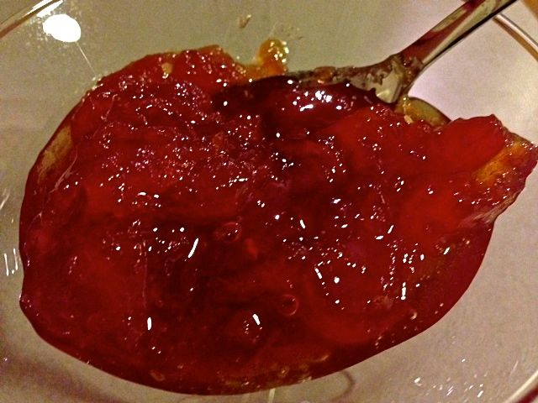

From the Dominican Republic, this recipe turns tomatoes into a sweet, candied treat.

Ingredients:
4 large, ripe Roma tomatoes
2 cups water
1¼ cups sugar
2 cinnamon sticks about 2” long
4 whole allspice berries

Preparation:
Bring a medium saucepan of water to a boil. Prepare a bowl of ice water to the side. Cut the stems out of the tops of the tomatoes and gently cut a small X in the skin of the bottom of each tomato (just cut skin deep); this will aid in peeling them. Submerge the tomatoes in the boiling water and boil 1 – 2 minutes, or until you see the skin start to loosen. Remove the tomatoes and place them in the ice water (I use tongs). Allow to cool, then peel the tomatoes. Cut them in half lengthwise and scoop out the seeds with a spoon. Set the tomatoes aside and toss out the boil-water.

In the saucepan, bring 2 cups of fresh water, the sugar, cinnamon, and allspice to a boil over high heat. Adjust the heat to the lowest setting and let steep for 20 minutes.

Add the tomatoes and bring to an active simmer on medium-low heat until the syrup has thickened, about another 30 minutes, breaking up the tomatoes with a wooden spoon as they get cooked and soften. Remove the allspice berries and cinnamon stick. Cool, then chill. Serve the tomatoes in a martini glass or other small, fancy serving dish.

