Spicy Cuban Pork Stew (recipe serves 2)

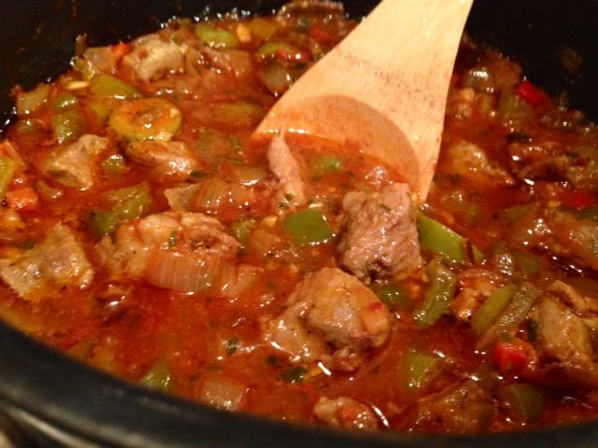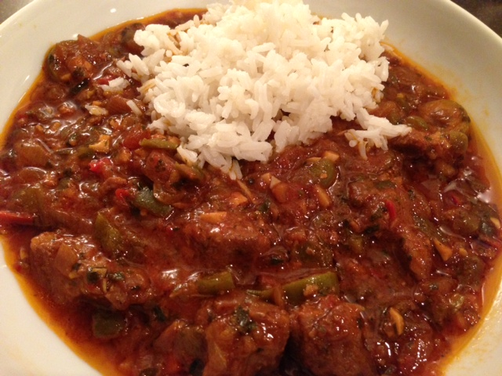

Marinated pork in limejuice and seasonings gives this dish a distinctive Cuban flair.

Ingredients:
½ - ¾ pound boneless pork steak, cut into 1-inch pieces
1 tablespoon lime juice
2 - 4 cloves garlic, minced
¼ teaspoon dried oregano
¼ teaspoon dried cumin
¼ teaspoon salt
¼ teaspoon ground, black pepper
1 tablespoon olive oil
8 ounces yellow onion, chopped
2 – 3 fresh chilies, chopped
1 small green bell pepper, seeded and cut into 1-inch pieces
¼ cup tomato paste
½ cup dry white wine
½ cup pork and/or chicken stock or broth
3 tablespoons (about ⅛ of cup) pimiento-stuffed olives, sliced
3 tablespoons (about ⅛ of cup) parsley, minced
½ - 1 teaspoon crushed red-pepper flakes, to taste
1 bay leaf

Preparation:
Combine pork, limejuice, 2 cloves’ worth garlic, oregano, cumin, salt, and pepper; mix well. Cover and refrigerate several hours or overnight, stirring once.

In a large saucepan over medium heat, warm oil. Add onion, bell pepper, chilies and remaining garlic; sauté until tender, about 5 minutes. Add the meat and sauté 5 minutes longer.

Add remaining ingredients and bring to a moderate boil. Boil until alcohol smell burns off, then reduce heat to very low, and simmer, covered (lid cocked) 2 – 3 hours, until pork is tender. Remove lid and simmer until slightly thickened, about 5 minutes longer. Remove bay leaf and discard. Serve with rice and tropical fruit.

