Spanish White Beans with Chorizo for Two (Alubias Blancas con Chorizo)

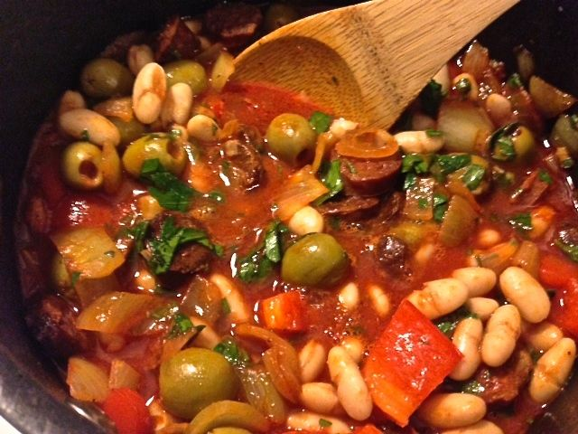

Quick, easy and very Spanish.

Ingredients:
½ Spanish/yellow onion, or a small one, chopped
2 cloves garlic, peeled and chopped (not too finely)
½ a red bell pepper, or a small one, chopped
6 – 8 ounces Spanish chorizo sausage (the hard-cured kind)
2 tablespoons olive oil
10 – 12 ounces Italian passata or tomato juice
1, 15-ounce can white beans (any kind you like), drained and rinsed
½ - 1 cup pimento- and/or anchovy-stuffed Spanish olives, whole
1 teaspoon smoky Spanish paprika
1 bunch chopped flat-leaf parsley
Ground, black pepper, to taste
Salt, to taste

Preparation:
Rinse the beans under cold water and drain. Cut the chorizo into slices about ¼“-inch thick.

Pour the olive oil into a large saucepan and heat over medium flame. When hot, sauté chorizo slices until brown and crispy around the edges. Add in the onion and bell pepper, stirring often. Take care not to burn the vegetables. If necessary, lower the heat. When the onion becomes translucent, add the garlic, olives, paprika and parsley. Add more olive oil if mixture begins to stick. Reduce heat to low.

Add the beans and tomato juice into the saucepan and stir, heating the mixture on low heat. Add salt and pepper to taste (I season everything as I go). Once the beans are hot, serve in bowls with slices of fresh baguette.

