Basic Spanish Tortilla (Spanish omelet) – serves 6

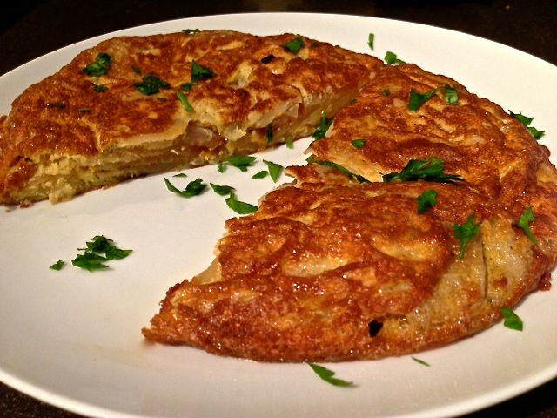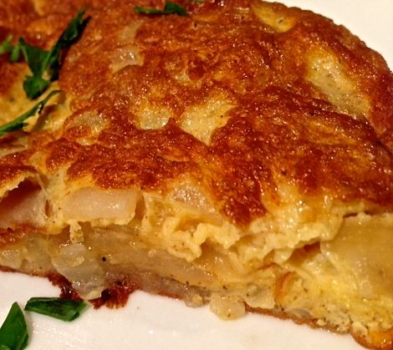

Along with paella, the ubiquitous Spanish omelet - tortilla de patatas - is perhaps one of the best-known Spanish dishes. It’s impossible to find a self-respecting tapas bar that doesn’t feature tortilla in its repertoire. As delicious as it is versatile, this Spanish staple lends itself to countless variations according to personal taste. Some cooks mix in mushrooms, beans, spinach, Serrano ham or tomatoes, while others choose to omit the onion and instead cover the tortilla in tomato sauce. Others still would never dream of serving the tortilla without heaping mounds of mayonnaise. Each region, and each tapas bar, will have its own variation of tortilla. This tapa can be served warm or cold.

Ingredients
Olive oil - enough for frying
5 large baking potatoes, peeled, sliced 1/8” thick (1 potato for two servings)
1 medium-small (about 4 ounces, 2 ounces for two servings) yellow onion, chopped
4 cloves garlic, minced (2 small cloves for two servings)
5 eggs (3 for two servings)
Salt, ground, black pepper and smoky Spanish paprika (pimentón), to taste

Preparation:
Sprinkle potato slices with salt, pepper and paprika. Heat the oil in a 9” skillet to medium-high (use the smaller 8” skillet for only two servings’ worth) and add the potato slices carefully, because the salt will make the oil splatter. Try to keep the potato slices separated so they will not stick together. Cook, turning occasionally, for 5 minutes. Add the onions and garlic, another sprinkling of salt and pepper, and cook until the potatoes are tender. Drain into a colander, leaving about 2 - 3 tablespoons of oil in the skillet.

Meanwhile, in a large bowl, whisk the eggs with a pinch of salt, pepper and paprika. Add the potatoes, and stir to coat with the egg. Add the egg-coated potatoes to the very hot oil in the skillet, spreading them evenly to completely cover the base of the skillet. Lower the heat to medium and continue to cook, shaking the pan frequently, until it’s half set.

Use a plate to cover the skillet and invert the omelet away from the hand holding the plate (so as not to burn your hand with any escaping oil). Add 1 tablespoon oil to the pan and slide the omelet back into the skillet on its uncooked side. Cook until completely set. Allow the omelet to cool, and then cut it into wedges. Season it with salt and sprinkle with lemon juice to taste (optional). Serve warm or at room temperature. I like garnishing it with a sprinkle of chopped parsley.

