Simple, but authentic Spanish Rice – makes 2 servings (double quantities for 4)

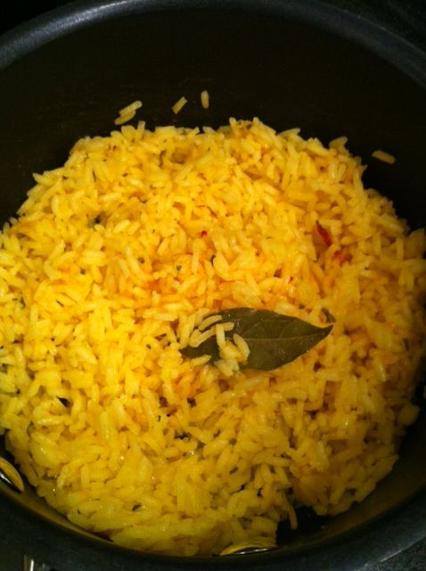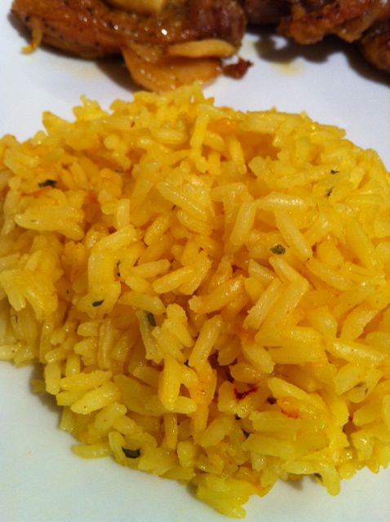

INGREDIENTS:

½ cup white, long-grain rice
1 cup water
½ teaspoon olive oil
1/8 teaspoon saffron threads, crushed
1/8 teaspoon salt
1/8 teaspoon garlic powder
1/8 teaspoon onion powder
1/8 teaspoon parsley flakes
1/8 teaspoon smoked, Spanish paprika
1 bay leaf

PREPARATION:

Place all ingredients in a medium-sized saucepan and bring to a boil. Reduce heat to lowest setting, cover saucepan tightly and let simmer for 15 minutes (do not remove the lid for the duration of the 15 minutes because the rice needs the pressure in the saucepan to cook completely through!).

After the 15 minutes, shut off the heat, uncover the saucepan, fluff the rice with a fork and remove the bay leaf.

You can let it sit there with the lid on and rest while you prepare the rest of your meal.

Rice freezes well.

