Spanish Pork with Lemon Sauce, Olives & Paprika – a favorite in Seville!

 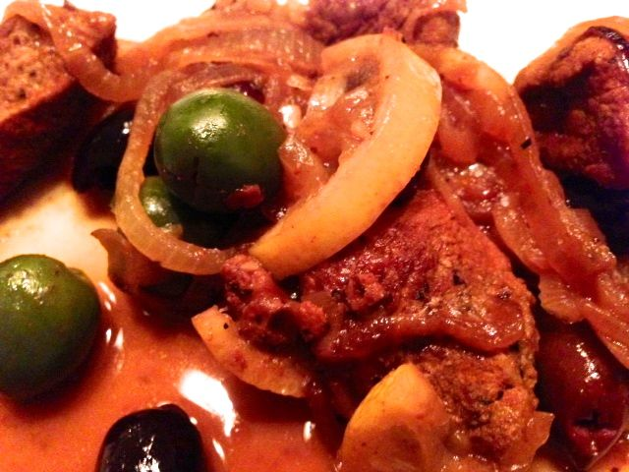 2 servings.

The simplicity of the ingredients for this famous dish, along with the presence of cinnamon in it, leads me to the conclusion that it is quite medieval in nature.

Ingredients:
½ pound pork tenderloin completely cleaned of all silver skin and fat cut into bite-sized chunks with kitchen sheers
3 ounces pitted green olives, sliced and/or halved (leave a few whole, though)
3 ounces pitted black olives, whole
1 lemon, washed, halved and sliced (leave the rind on, but be sure to get all the seeds out!)
1 medium Spanish/yellow onion, peeled, halved and sliced
¼ teaspoon ground cinnamon
½ teaspoon ground cumin
2 teaspoons sweet, Spanish paprika
Olive oil (for frying the meat)
½ cup of good-quality, white wine (the kind you drink!)
¼ teaspoon salt
¼ teaspoon ground, black pepper

Preparation:
Cut the meat into 1” pieces and rub with the spices; leave to marinate for about an hour in the fridge.

Brown the onion in a frying pan in a little olive oil (I like to add a couple cloves of thinly-sliced garlic with the onions). When caramelized, add the meat and brown well. Add the lemon slices with their rinds to the meat, the olives and the white wine. Zest the end-pieces left over from the sliced lemon over the mixture and leave it to cook with the lid on for half an hour, stirring occasionally, over very low heat so it just percolates a little.

