Spanish Pea Soup for Two

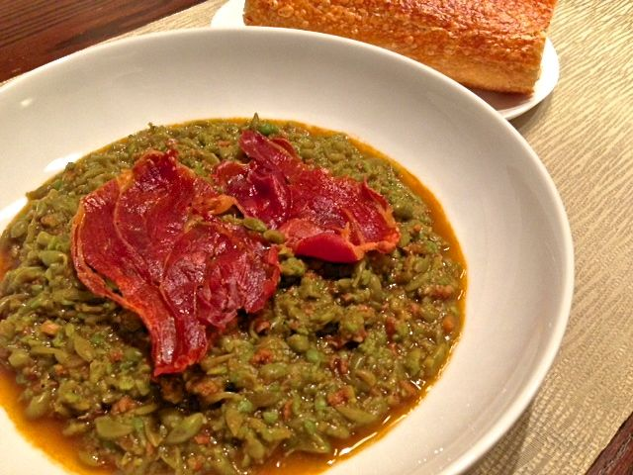

Ingredients:
4 ounces Spanish-style chorizo, diced
¼ cup (2 ounces) chopped shallots
2 cloves garlic, minced garlic
2 cups ham or pork stock/broth
1 pound frozen peas
1 teaspoon salt and ½ teaspoon freshly-ground, black pepper
1 teaspoon pimentón (smoky Spanish paprika)
4 paper-thin slices Spanish jamón (Sendik’s deli)
Olive Oil

Preparation: Preheat oven to 425° F.

In a large saucepan, heat a tablespoon olive oil over medium heat. Add the shallots and diced chorizo; sauté until the shallots are translucent and the chorizo browned and crisp. Add the garlic and sauté a minute longer. Add the stock, frozen peas, salt, pepper and paprika; bring to a boil. Lower the heat and simmer 5 minutes.

Mash the peas thoroughly with a potato masher for a coarser texture of soup (which I like). Otherwise, you may transfer the soup by the cup to a food processor and pulse until pureed as smoothly as you like. Pour the soup back into the pot and keep warm on low heat ready to serve.

I saw Ina Garten do the following with prosciutto slices on TV with her Spanish pea soup recipe. I thought it makes for a nice touch, but Spanish jamón (very similar to Italian prosciutto) is more appropriate! Place the jamón slices in a single layer on a baking sheet and bake 8 - 10 minutes, until browned around the edges and crispy.

Serve soup with slices of crispy jamón on top. Break up the crispy jamón with your spoon, stirring it into the soup as you go! Serve with crusty bread on the side.

