Paella (pronounced “pie-ay-yah”)

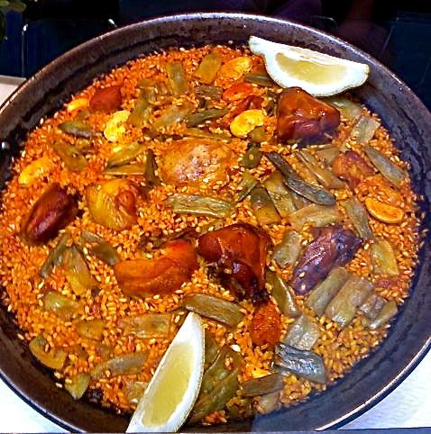

Though popular all over Spain today, this dish was originally created in the areas around Valencia, Spain. Valencianos like to include rabbit in theirs. This recipe actually makes more like four servings.

Ingredients:
2 tablespoons regular olive oil, divided
¼ pound peeled/de-veined medium shrimp (that’s about 2 to 4 shrimp per serving, depending on size)
½ pound spicy chorizo sausage, sliced into ¼ to ½-inch pieces
¼ pound skinless, boneless chicken breast, cut into 1-inch cubes
1 medium Spanish/yellow onion, diced
2 cloves garlic, minced
1½ cups short-grain (Arborio) rice
¼ teaspoon each saffron threads (soaked in 1 tablespoon warm water), paprika & ground turmeric
1 – 2 pounds fresh tomatoes, peeled and finely diced, or a 14½ -ounce can peeled, whole tomatoes and their juice, crushed by hand
1½ pints chicken broth, or two 14.5-oz. cans chicken broth will do
1 teaspoon each salt & freshly ground black pepper
½ teaspoon garlic powder
1 cup frozen green peas

Preparation:
In a heavy, 12-inch skillet, heat 1 tablespoon oil over medium-high heat. Sauté the shrimp until they just turn pink on both sides, about 5 minutes (do not overcook!). Transfer them to a warm bowl; season lightly with a little of the salt, a little of the pepper and all of the garlic powder.

Heat up the rest of the oil in the pan over medium-high heat, add the chicken and sausage; fry the meat until browned. Add the onion, sauté until translucent. Add the garlic and rice, stirring to coat the rice thoroughly. Cook 1 to 2 minutes, until the rice turns translucent.

Next, stir in the rest of the salt and pepper, the saffron threads and their soak-water, the paprika, turmeric, tomatoes, and broth, scraping up any browned bits from the bottom of skillet.

Bring the mixture to a boil, then reduce the heat to the lowest setting. Cover the pan with a tight-fitting lid and cook 20 minutes until the rice is tender and has absorbed most the liquid – do not take the lid off during the 20-minute cooking time because the rice needs the pressure to cook all the way through.

At the end of the 20 minutes, take the lid off, stir in the frozen peas and cooked shrimp. Uncovered, turn the heat up to a very high setting and let it cook 4 minutes so that a classic, crispy bottom crust forms. Slice out quarter-sections with a stiff spatula, scraping up as much of the crispy bottom layer as you can with each portion. Serve immediately. Note that this does not reheat well.

