In Spain, this is called “Champiñones, Pimientos y Ajo.” Recipe makes two servings.

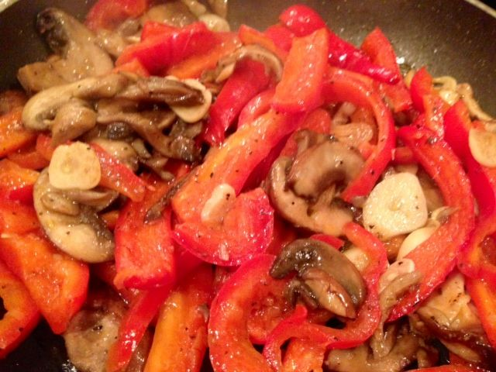

Mushrooms and peppers sautéed with plenty of garlic is a versatile dish. It makes a good side dish to accompany meat, chicken or eggs, but can be served as a “tapa” with slices of rustic bread. Preparation is simply slicing the mushrooms, pepper and garlic, then sautéing them in olive oil. I like sneaking some red chili in!

Ingredients:
4 ounces white or brown mushrooms, washed, stemmed and thinly sliced
1 small red pepper
2 - 3 garlic cloves, peeled and thinly sliced
Extra virgin olive oil for sautéing
Salt to taste

Preparation:

Rinse red pepper and remove stem. Cut pepper in half lengthwise, remove seeds and devein. Slice into thin strips.

Pour 2 tablespoons of extra virgin olive oil into a small, heavy-bottomed frying pan. Heat on medium. When oil is hot, add mushroom, pepper and garlic slices. Sauté until vegetables are soft, being careful not to burn the garlic or over-cook the vegetables.

