Pollo al Ajillo (“poyo-ahl-ahee-yo”) - Spanish Lemon-Garlic Chicken (serves 2).

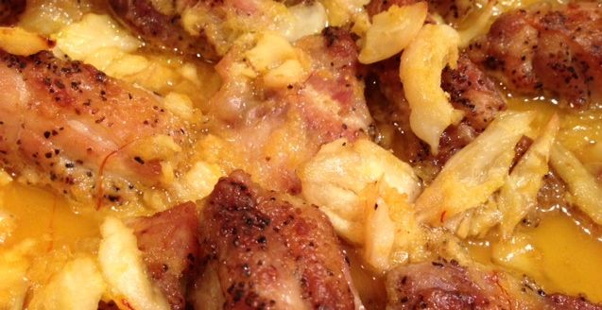

The following recipe includes three, quintessential ingredients of cooking in the area around Spain’s old, imperial capitol city, Toledo: Garlic, saffron and lemons. The garlic and fresh lemon lend such a sunny aroma to the dish that perfectly compliments the warm, yellow color provided by the saffron.

Ingredients:
8 ounces of chicken thighs, bone-in with the skin on, but have your butcher debone it and cut it into 2” - 3” pieces for you.
½ head of garlic - peeled and crushed with a little salt
½ cup water or chicken broth
Juice and zest of 1 lemon (about 4 tablespoons juice)
⅛ teaspoon saffron threads, crumbled
1½ teaspoons olive oil
Salt and freshly ground black pepper, to taste

Preparation:
Preheat oven to 340° F.

Heat oil in a medium skillet over medium heat. Season the chicken pieces with a little salt and pepper, then sauté in skillet until golden-brown.

Place browned chicken pieces in a shallow casserole/baking dish.

Drain all but 1 teaspoon oil from the skillet; briefly sauté the crushed garlic in the hot oil, no more than 1 minute. Stir in the water or broth, zest of lemon and saffron into the skillet. Bring it to the boil and simmer 3 minutes. Remove from heat and mix in lemon juice. Pour over chicken in the casserole.

Cover and bake for 30 - 45 minutes, until chicken is tender and thoroughly cooked.
Uncover for last 15 minutes of baking. Garnish with a little chopped, fresh parsley, if you like, and serve with white or Spanish-style rice, crusty bread and the recipe for Spanish Mushrooms, Peppers & Garlic.

