Andalucian Beef with Green Olives
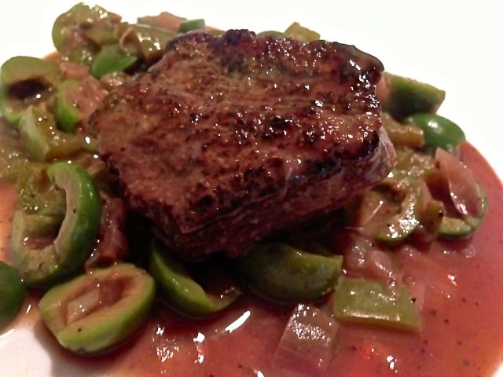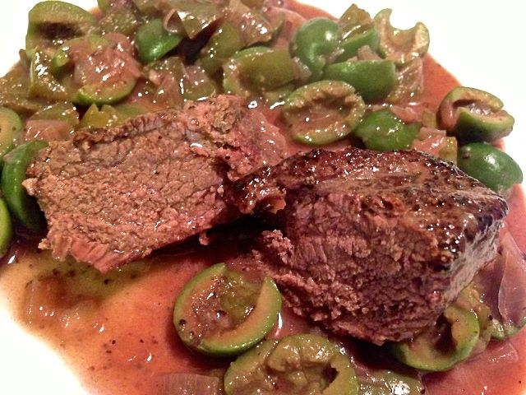
This beef recipe is one of only a few traditional beef recipes from south-central Spain. In general, meat dishes in Spain tend to be predominantly pork or lamb and, in Andalucía, it’s rare to find beef recipes on the menu. The use of olives in this dish adds some real Spanish flavor and compliments the beef extremely well.
Ingredients:
½ pound beef (topside/sirloin is good), cut into 2 steaks
1 small yellow/Spanish onion, diced
1 small green pepper, diced
1 tablespoon all-purpose flour
½ cup red wine
Olive oil, to seer the steaks
3 – 4 ounces pitted green olives, halved
½ teaspoon salt
¼ teaspoon ground, black pepper

Preparation:
Season the beefsteaks with salt and pepper (I like to also sprinkle them with a little granulated garlic powder), then fry in a very small amount of oil to seal; add to a deep pot or saucepan.

Sauté the onion and pepper over medium heat until the onion is softened, add the flour and cook for 2 minutes before transferring to the pot with the beef.

Add the wine and 1 cup of water, partially cover and cook over low heat for 1 hour.

Add the olives and cook for a further 20 minutes.

