Sopa de Lima – Mexican Sweet Lime Soup (recipe makes 4 servings)

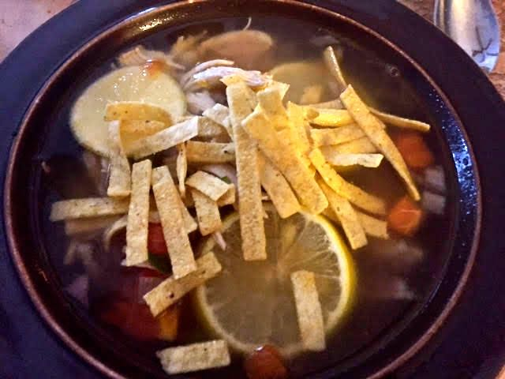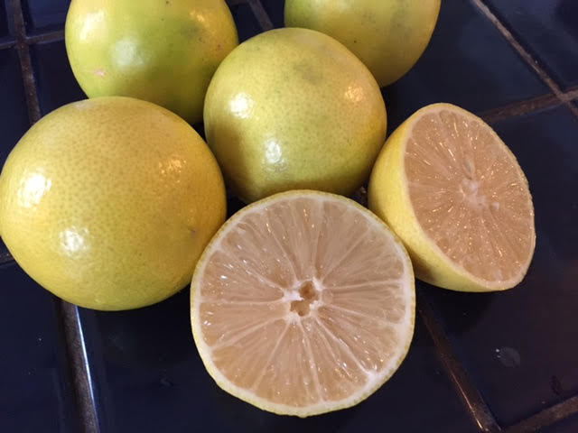

Mexican limas (called “sweet limes” in English) are native to the Yucatán peninsula and are neither limes nor lemons. They’re small, round, yellow citrus fruit that are very sweet and lend a very delicate citrus note to the soup. You can get them at most Mexican grocery stores.

Ingredients:
4 limas (1 per serving) – if you can’t find any, substitute green limes for them
5 whole cloves garlic, unpeeled (I do like to slice off the tough, woody tips, though)
1 pound boneless, skinless chicken breasts.
3 bay leaves
3 whole cloves
1 teaspoon oregano (preferably the Mexican variety)
½ teaspoon thyme
Salt and ground, black pepper
½ red onion, chopped
1 green bell pepper, chopped
2 large Roma tomatoes, chopped
Fried tortilla strips, to taste (make your own by cutting corn tortillas into thick straps and frying them in hot oil for a few seconds until browned, but they sell them already fried at Mexican groceries)
Oil, for frying vegetables.

Preparation:
In a large, dry pot or Dutch oven, char the garlic cloves until blackened in spots all over.

In the pot, make a simple chicken broth by putting the chicken breasts, the bay leaves, cloves, oregano, thyme, 2½ teaspoons salt and black pepper, to taste, in with the unpeeled, charred cloves of garlic. Add in 8 cups water, bring to a light simmer over medium-low heat, cover the pot and let simmer for 40 minutes. Remove the chicken breasts from the broth and let them cool. Strain the broth and set it aside.

Wipe the pot dry and heat up a little oil over medium heat; sauté the onions, tomatoes and bell pepper until soft. Season with salt and pepper.

Shred the chicken while the vegetables soften in the pot. Add it and the strained broth to the pot. Bring back to a simmer. Cut two of the limas in half and slice the other two. Squeeze the juice from the halves into the pot and stir in the lima slices. Serve hot garnished with fried tortilla strips, sliced avocado, sliced chilies or a sprinkling of hot sauce, if you like.

