Sautéed Ripe Plantains (Plátanos Maduros)

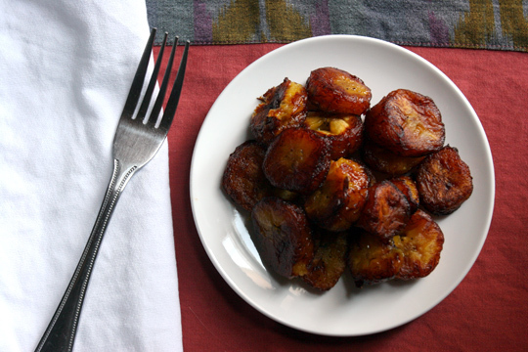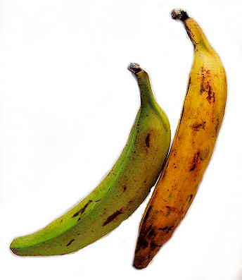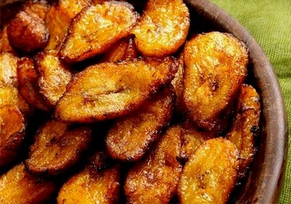

Plantains, a staple of Latino cuisines, are usually bought when they’re green, and then, like common bunch bananas, just get riper and sweeter until they rot. Before that happens, they’re black: the flesh is soft, delicate and pink-tinged. At this stage, they are sweet enough to make into dessert, though most often they’re used to produce one of the easiest and most delicious weeknight side dishes a home cook can have in his or her repertory: plátanos maduros.

Ingredients for Two Servings:
1 yellow-black or black plantains, peeled
Neutral oil, like grapeseed, corn or canola, as needed
Salt and pepper to taste
Lime wedges

Preparation:
Peel plantain and cut into 1” pieces. Grease the bottom of a large skillet with oil and place over medium heat; a minute later, add plantain pieces.

Cook, turning as necessary and adjusting heat so plantain pieces brown slowly without burning, 10 to 15 minutes.

Serve hot, sprinkled with salt, pepper and limejuice.

