Baked Refried-Beans Casserole for Two

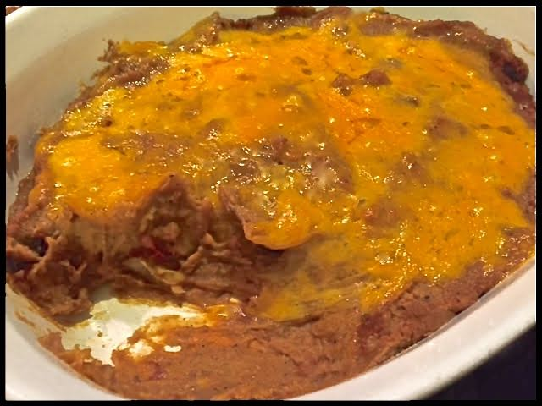

Ingredients:
1 16-ounce can refried beans (or make your own)
½ red bell pepper, chopped
¼ medium-sized onion, chopped
¼ cup tequila
4 cloves garlic, smashed and minced
Jalapeño peppers, chopped (to taste)
1 tablespoon butter
½ teaspoon salt
½ teaspoon Mexican chili powder
¼ teaspoon ground, black pepper
1 cup grated Cheddar and/or Pepper Jack cheese, divided

Preparation:
Preheat oven to 350° F.

Heat the butter in a saucepan; sauté the bell pepper and onion in the butter until caramelized. Pour in the tequila. Let it simmer until nearly all of it evaporates away.

Stir in the beans, garlic and chilies. Season it all with the salt, chili powder and black pepper. Stir in half the cheese until nicely melted and integrated into the beans.

Transfer the beans/cheese mixture to a greased casserole dish. Use a spatula to spread the top out so it’s flat and even. Cover with the remaining cheese and bake in the oven for about 20 minutes, until the cheese is melted and the beans are nice and bubbly.

