Croquettes de Patata (Potato Croquettes) – recipe makes 8 croquettes

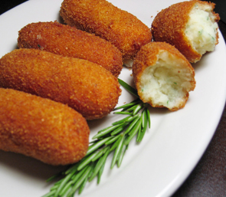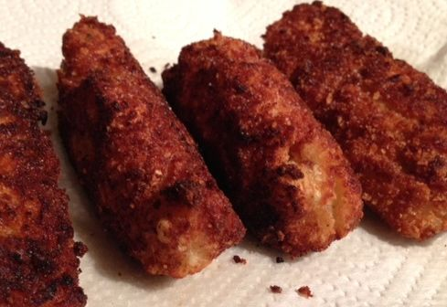
What they’re supposed to look like. What mine look like (but they still taste awesome!).

These are ubiquitous in Spain – every restaurant and tapas bar offers them as a side dish or snack (see the note below before starting this recipe)! These are actually quite popular all over Europe (in Germany, they’re called Kartoffelkroketten).

Ingredients:
2 cups mashed potatoes
½ teaspoon salt
½ teaspoon ground, black pepper
½ teaspoon baking powder
1 egg yolk – set egg white aside.
2 tablespoons all-purpose flour, plus ½ cup divided on a plate
3 tablespoons milk or cream
1 cup breadcrumbs

Preparation:
Mix together well the mashed potatoes, salt, pepper, baking powder, 2 tablespoons flour, the egg yolk and milk/cream. Shape the mixture into traditional croquette cylinders, balls or patties – I use two tablespoons to make them into egg shapes.

Let the croquettes rest in the fridge while you bring ¼ inch oil to 350° F. in a large frying pan.

With the ½ cup flour on the first plate, beat the egg white until foamy and pour it out onto a second plate. Spread the breadcrumbs out on a third plate. Roll the croquettes first in the ½ cup flour on the first plate, then dip them thoroughly in the egg white, then dredge them each through the breadcrumbs, coating them thoroughly.

Fry the croquettes in the hot oil until they are golden brown. You can also bake these in a 425° F. oven for about 20 minutes, until golden brown.

Note: You can add into the potato mixture a little grated cheese, a few bacon bits, flaked tuna, a little minced, cooked ham, chives, minced parsley, garlic, fried onion, Spanish paprika or whatever else your heart desires!

