Plátanos Maduros – Fried, Mature Plantains

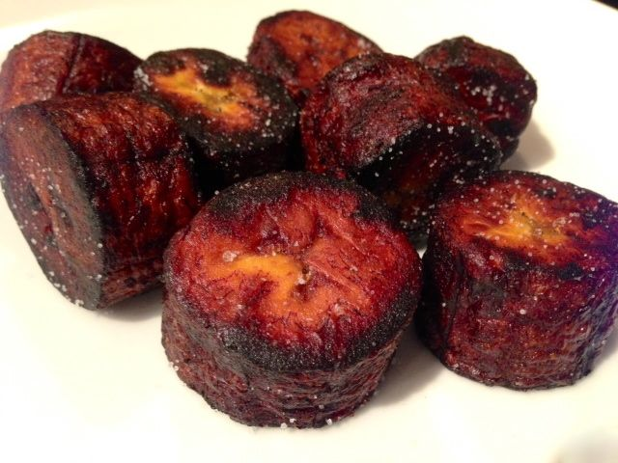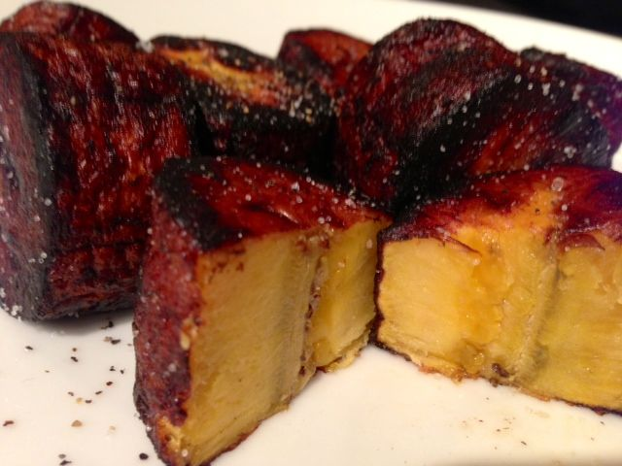

Plantains, a staple of Latin-American cuisines, are usually bought and prepared when they’re green, and eaten as a starchy side dish. Like the much smaller bananas Americans all know and love, they gradually get riper and sweeter, turning very black with soft flesh tinged with pink that tastes sweet and delicate. At a very mature stage of ripeness, they are sweet enough to make into dessert and also into this sweet and savory side dish, the taste of which reminds me a lot of candied sweet potatoes.

Ingredients for Two Servings:
1 yellow-black or black plantain, peeled
Vegetable oil – enough to fill pan ¼“ – ½“ deep
Salt and pepper to taste
A few lime wedges or limejuice for dressing the fried plantains

Preparation:
Peel plantain and cut into 1” pieces. Heat enough oil in a medium-sized skillet so that it will rise midway up the plantain sections over medium heat; add plantain pieces.

Fry, turning as necessary and adjusting heat so plantain pieces brown slowly without burning, 10 minutes. Remove to paper towels to soak up excess oil – sprinkle with a little salt immediately after they come out of the oil.

Serve hot, sprinkled with more salt (to taste), black pepper and limejuice.
Serve hot, sprinkled with salt, pepper and limejuice.

