Piri Piri Chicken for Two

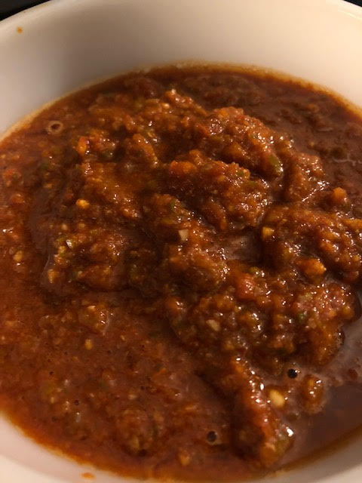

Piri Piri chili marinade is Portuguese in origin, but it has made its way across the globe. It’s very popular in Brazil, and this recipe is a South-African take on it. It’s enough to dress half a whole chicken (enough for two people). You may certainly use it to marinate and cook other kinds of meat, and also seafood!

Ingredients:
Half a chicken, cut into pieces (or enough pieces of your choosing for 2 people)
4 fresh, red Fresno or Jalapeño chilies, rough-chopped (if you can find mostly red Jalapeños, use those because Fresnos are even spicier than Serrano chilies)
3 cloves garlic, smashed
1 tablespoon sugar
4 tablespoons red wine vinegar
2 tablespoons, plus 2 teaspoons lemon juice (the juice of about ½ a large lemon)
1½ teaspoons ground coriander
1½ teaspoons ground cumin
1½ teaspoons smoky paprika
2 teaspoons salt
4½ teaspoons New Mexico or California chili powder
Fresh cilantro (optional)

Preparation:
Thoroughly blend together the ground coriander, cumin, paprika, salt and chili powder. Reserve a tablespoon of it and put the rest in a food processor. Rub your chicken really well with the reserved mixture (under the skin, as much as possible).

To the mixture in the food processor, add the fresh chilies, garlic and sugar; pulse well. With the food processor running, add in the vinegar and lemon juice. Brush the chicken with 4 tablespoons of it and let sit for 45 minutes to 1 hour before grilling or baking at 425°F for 45 to 50 minutes before brushing with another tablespoon or so of the sauce. Put it back in the oven or on the grill for another 10 to 15 minutes.

Let the chicken rest for 10 minutes after it’s finished cooking. Add some chopped cilantro to your remaining sauce, if you like, and give the chicken another good brushing with sauce before serving with the remaining sauce on the side.

