Pinchitos Morunos (small, spicy Moorish kebabs) for Two

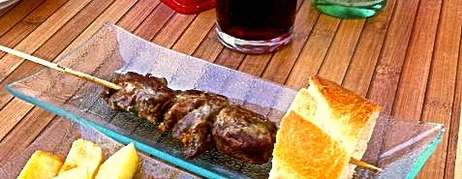

Europe's first kebabs were brought by the Arabs from Africa. Pinchitos morunos are eaten everywhere in Spain as a tapa, though nowadays they are made of pork, rather than lamb.

Spices for them are sold ready-mixed in the south. Curry powder contains cumin and very similar herbs and works great.

Note that the preparation time for this tapa is 25 minutes, + 2 hours marinating time.

Special Equipment: Two metal or wooden skewers.

Ingredients:
½ pound lean pork (tenderloin), cut into 6 – 8 small cubes
1 garlic glove, finely chopped
1 teaspoon salt
½ teaspoon mild curry powder or pinchito spice mixture
¼ teaspoon coriander seeds
½ teaspoon smoky Spanish paprika
⅛ teaspoon dried thyme
Ground, black pepper, to taste
4 teaspoons olive oil
1½ teaspoons lemon juice

Preparation:
If using wooden skewers, soak them in water for 20 minutes.

Crush the garlic with the back of a knife o0n a board, then work in the other ingredients.

Skewer the pork, 3 - 4 cubes to a small stick, and marinate them in a shallow dish with the herbs (pinchito spice, coriander, paprika, and thyme), turning so they are well coated. Leave at least a couple of hours.

Spread the pinchitos out well on a barbecue grill or on foil under your oven broiler. Cook them using a high heat for about 3 minutes on each side.

