Pico de Gallo - savory, spicy Mexican (Aztec) salsa-salad relish

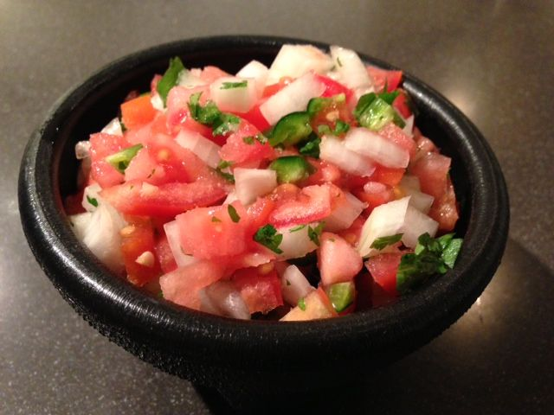 Recipe makes 2 servings.

Pico de gallo is means “rooster’s beak” in Spanish – maybe because it’s spicy and pecks one’s tongue when eaten?

Ingredients:
1 medium-small “beef steak” tomato, diced
1 small, white onion, diced
1 medium jalapeño chili, diced
1 tablespoon fresh cilantro, chopped
1 tablespoon lime juice
⅛ teaspoon salt
⅛ teaspoon garlic powder

Preparation:
Mix all ingredients well, chill before serving.

