Picadillo (“peek-a-dee-yo”) – versatile, savory ground meat from the Latin Caribbean. Recipe makes 2 servings.

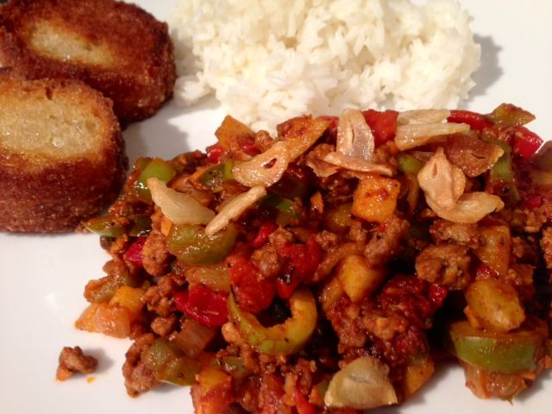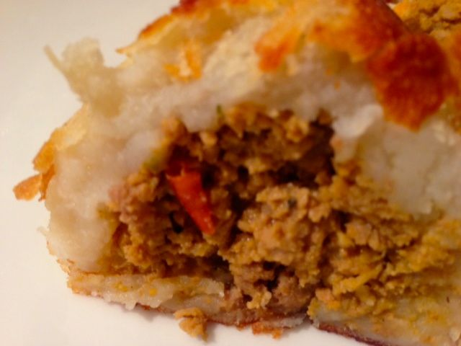

Ingredients:
½ pound ground lean pork and/or beef (I use sirloin)
4 ounces Spanish-style tomato sauce
6 – 7 ounces new potatoes, peeled, cut into small dice and boiled 10 minutes
¼ - ½ cup olive oil
1 small (4 ounces) yellow/Spanish onion, finely chopped/diced
1 medium green bell pepper, finely chopped/diced
2 - 3 cloves fresh garlic, minced
1 fat clove fresh garlic, thickly sliced
¼ cup (2 ounces) pimento-stuffed green olives (use the giant kind), carefully sliced
4 tablespoons raisins (I leave them out)
1½ teaspoons each capers (the small kind), white-wine vinegar, lemon & limejuice
2 tablespoons paprika
⅛ teaspoon sugar
½ teaspoon salt & ¼ teaspoon ground, black pepper
3 ounces sliced or diced pimentos (they sometimes come in the little jars)
4 slices French bread
2 servings cooked, white rice

Preparation:
Heat two tablespoons of the oil in a medium skillet over medium heat. Sauté the onion, the minced garlic and bell pepper until soft and translucent. Add in the ground meat and brown it, crumbling fine until no red remains and it’s cooked through.

Stir in the remaining ingredients (except the sliced garlic, the rest of the oil and the bread slices – the potatoes are optional, but I like to include them). Cover and simmer on very low heat for at least 20 minutes, stirring occasionally.

While the picadillo simmers, heat the rest of the oil in a wide skillet with the sliced garlic on very low heat. Wait until the oil is nicely infused with the garlic’s essential oils (the garlic should just be laying there in the oil, with tiny bubbles surrounding each slice). Let the garlic infuse the oil about 15 minutes, then remove the garlic slices completely from the oil with a fork or slotted spoon. Turn up the heat to medium-high. When the oil is good and hot, fry your bread slices in it until nicely browned on both sides.

Serve the picadillo with cooked, white rice and the fried bread slices.

Picadillo makes for a wonderful filling for empanadas. Or make Papas Rellenas (stuffed potato balls): Mix together 2 lbs. cold mashed potatoes with 2 lightly-beaten eggs and 2 teaspoons cornstarch.
Spread a couple of spoonfuls of the potato in one hand and make an indentation in it in which to fill with picadillo. Close it up into a ball around the filling with another spoon-full of potato mix. Repeat as necessary until you have as many as you want. Place on cookie sheet and bake at 450° F. for 20 minutes, or until hot and golden.

