Peruvian Chicken for Two

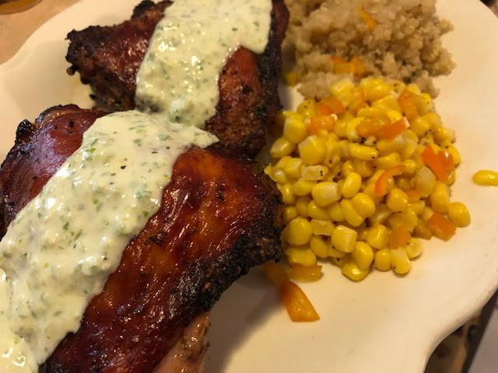
Ingredients:
4 – 6 small bone-in chicken thighs with skin (about 2 pounds)
½ - ¾ cup fresh cilantro leaves
¼ cup soy sauce
5 teaspoons distilled white vinegar
1½ teaspoons vegetable oil (I use peanut oil)
1½ teaspoons ground cumin
¾ teaspoon hot paprika
½ teaspoon dried oregano
⅛ to ¼ teaspoon cayenne pepper
3 – 4 cloves garlic, minced

Make a Creamy Green Sauce first by combining the following:
2 – 3 small scallions, trimmed and halved, 1 sliced green Serrano chili with seeds and ribs, the juice of a small lemon, 1 ounce crumbled goat cheese (¼ cup), 1½ teaspoons vegetable oil, ¼ teaspoon salt, ⅛ teaspoon black pepper, and ¼ cup half-and-half in a blender or food processor; puree until smooth. Sauce can be made ahead of time and refrigerated over night.

Preparation:
Combine the cilantro, soy sauce, vinegar, vegetable oil, cumin, paprika, oregano, and the desired amount of cayenne in a blender; press in the garlic (about 1 tablespoon) and puree for the marinade. Combine the marinade and the chicken in a Ziploc bag and set aside at room temperature at least for 30 minutes, turning bag occasionally.
Place an oven rack on the top shelf of the oven and preheat the oven to 450°F. Drain the chicken, discarding the marinade, and pat the chicken dry. Arrange the chicken on a baking rack in a shallow roasting pan or foil-lined baking sheet. Roast for 20 to 30 minutes, or until crispy and cooked through. Let rest for 10 minutes before serving drizzled with the green sauce, with steamed quinoa and steamed corn.

