Patatas Bravas (crispy-fried, spiced potatoes smothered in tangy sauce) – a classic!

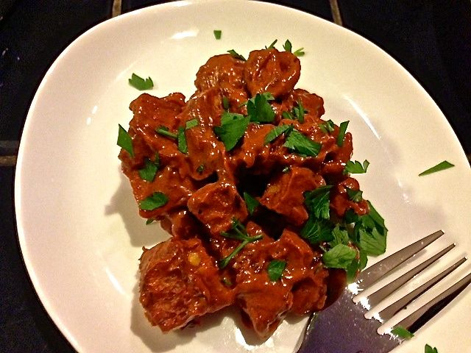

Patatas bravas means “spicy potatoes” and is a basic, traditional tapa which is popular in elegant big-city establishments as well as in modest village hostelries. Like most tapas, each bar and restaurant has its own recipe. Savor this tangy favorite with a glass of crisp white wine.

Ingredients:
5 teaspoons of olive oil
1 large Russet potato, peeled, and cut to 1” cubes
1 small onion (about 2 – 4 ounces), minced
2 cloves garlic, minced
Salt and ground, black pepper, to taste
5 teaspoons smoky Spanish paprika
½ teaspoon ground cayenne pepper
¼ teaspoon ground thyme
¼ cup ketchup
¼ cup mayonnaise
Chopped parsley, to garnish
½ cup olive oil, for frying

Preparation:
In a saucepan, heat the 4½ teaspoons olive oil over medium heat. Add the onion and garlic and sauté until the onion is soft (I like to caramelize them a bit). Turn off the heat, then add the paprika, cayenne, and thyme, stirring well. Transfer to a bowl and add the ketchup and mayonnaise. Season with salt and pepper to taste. Set aside.

Fry the potatoes in the ½ cup of oil in a saucepan until cooked through and golden-brown, stirring occasionally. Drain the potatoes on paper towels, season with salt and set it aside.

Bring the sauce to room temperature. Mix the potatoes with the sauce immediately before serving to ensure that the potatoes retain their crispness. Garnish with chopped parsley and serve warm.

