Fried Potatoes & Chorizo – this dish is called “Batatas e Chouriço” in Brazil and “Papas con Chorizo” in the rest of Latin America (recipe serves 2).

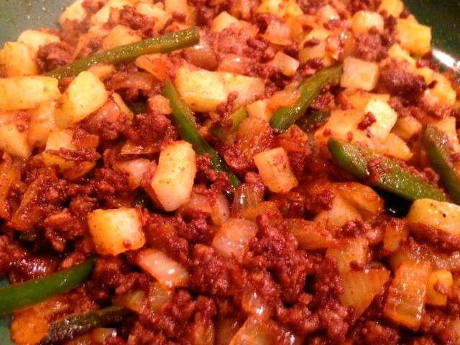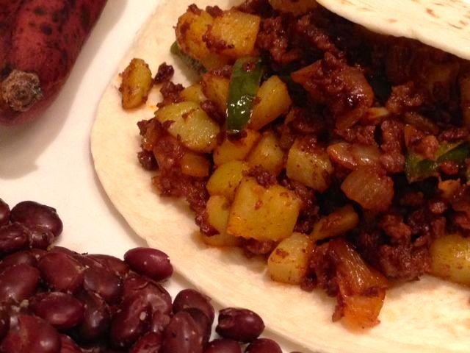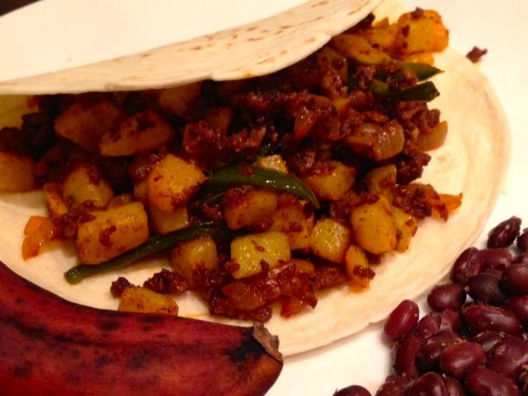

Ingredients:
½ pound chorizo sausage, bulk/crumbled out of the casing
5 ounces onions, chopped into small dice
8 ounces potatoes, peeled, diced small & boiled for 10 – 13 min.
2 fresh jalapeño peppers, julienned
½ teaspoon salt
¼ teaspoon ground, black pepper
2 - 4 flour tortillas (1 - 2 per serving)

Preparation:
Drain the boiled potatoes thoroughly.

In a medium skillet over medium heat, fry the chorizo until crumbled well and cooked through. Add in the onions & jalapeño pepper, salt & pepper; sauté until onions are soft and translucent. Add the potatoes; cook another few minutes, until the potatoes are colored.

Serve hot with warmed flour tortillas and seasoned black beans on the side.

