Mom’s “Taco Soup” Chili recipe (modified – serves 2).

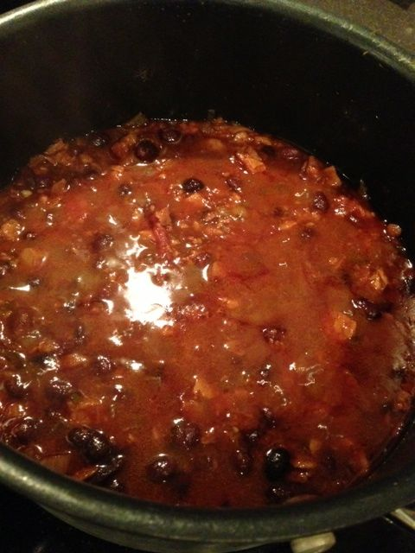

My mom’s recipe for chili – for 4 to 6 servings, it called for 1½ pounds ground beef, a large onion, 1 teaspoon of crushed red-pepper flakes instead of fresh, chopped chilies, double the celery salt, no lime juice, no chili powder, no ground cumin, and three 14-ounce cans of beans: Black beans, red-kidney and pinto beans. This is my take on it.

Ingredients:
½ pound lean ground beef (see note)
1 small, Spanish (yellow) onion
1, 14-ounce can black beans, drained and rinsed
1, 14-ounce can imported Italian San Marzano tomatoes with their juices, crushed by hand
½ teaspoon crushed, red-pepper flakes
2 - 3 fresh Serrano or other green chilies, finely chopped
2 - 3 cloves garlic, minced
1 teaspoon chili powder
¼ teaspoon celery salt
¼ teaspoon ground cumin
1 tablespoon lime juice
Salt and ground, black pepper, to taste
½ cup hot water with 1 beef bouillon cube dissolved in it

Preparation:
Season meat with salt and black pepper. Brown meat and add onion, garlic and chilies, sautéing until golden (season the vegetables with a light sprinkling of additional salt).

Add remaining ingredients, season with just a tad bit more salt and bring to a boil; lower heat to a gentle simmer and cook 45 minutes to an hour. Check seasoning before serving.

Note: I make a vegetarian version of this replacing the beef with 6 ounces of Morning Star brand faux-meat crumbles and replacing the beef bouillon with a vegetable-bouillon cube. I first fry down/caramelize the onion, garlic and chilies before adding in the crumbles with plenty of olive oil to fry to a moderate crisp before adding in the rest of the ingredients to stew.

