Mexican Yellow Rice (recipe serves 2)

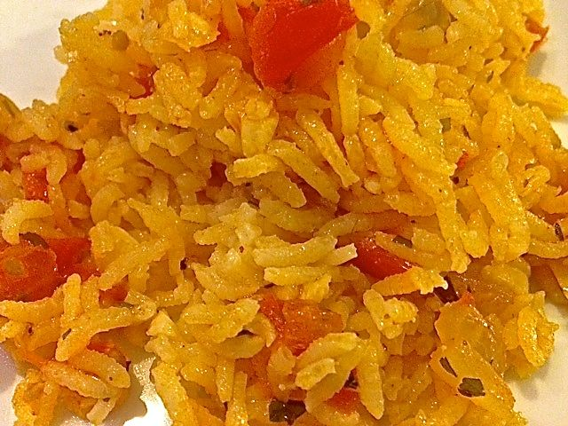 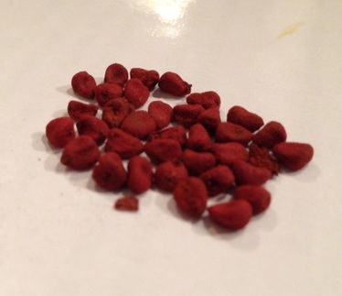 These are achiote (annatto) seeds.

Ingredients:
¼ teaspoon saffron threads, crumbled and steeped 15 minutes in a tablespoon of boiling water, or see recipe to substitute with ½ teaspoon achiote (annatto) seeds
½ cup long or extra long white rice
1 tablespoon vegetable oil
3 tablespoons (about 1 ounce) white onion, chopped
3 tablespoons (about 1 ounce) red tomato, chopped
1 garlic clove, minced
1 cup chicken broth
½ teaspoon salt, or to taste
¼ teaspoon Mexican oregano
¼ teaspoon fresh cilantro, parsley and/or chives, chopped (dried will do fine)

Preparation:
Place rice in a bowl, cover with boiling water, and let steep for 10 minutes. Drain, rinse with cold water in a sieve until the water runs clear, then drain thoroughly.

Heat the oil in a small saucepan over medium-high heat. If you are using achiote seeds instead of saffron, just let ½ teaspoon of them cook in the oil for 2 – 3 minutes (careful not to burn them!), then fish them out after the oil turns deep red in color before adding in the rice. In the hot oil, sauté the drained rice for 1 – 2 minutes; cook until the rice turns chalky white - it should sound and feel heavier, as if you were moving sand in the pot, about 4 – 5 more minutes. Stir in the onion, tomato, garlic, oregano and cilantro, parsley and/or chives, and simmer until soft.

Pour in the chicken broth, saffron mix, and salt and stir thoroughly. When the liquid starts to boil, cover the pot, lower the heat to low and continue cooking for 15 minutes, or until the rice is cooked through and the liquid has been mostly absorbed. Do not remove the lid for at least 15 minutes – resist urges to stir!

If the grains don't seem soft and cooked through, add a bit more chicken stock or water and let it cook for another 5 minutes or so. Turn the heat off and let it sit covered for 5 to 10 minutes. Fluff with a fork and serve.

