Mexican Taco Poblano-Cheese Salsa (Rajas) for Two

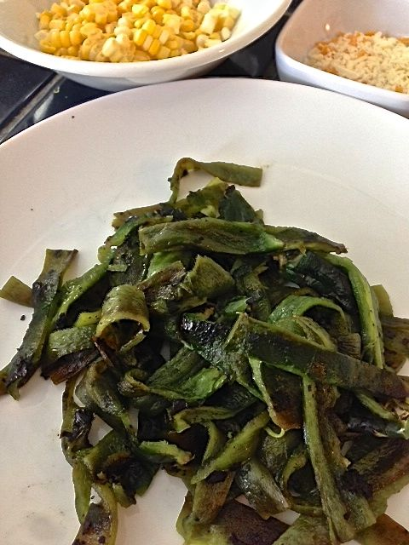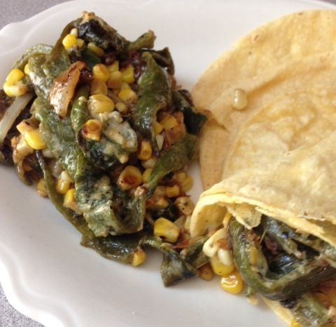

This creamy dish is a Mexican table staple at any meal for filling tortillas or putting in quesadillas. They can be made with any kind of chili pepper, but I like making them with mild poblano chilis, as in this easy recipe.

Ingredients:
3 fresh poblano chilis (or canned, peeled)
4 teaspoons vegetable oil
1 small white onion, thinly sliced
1 ear corn, kernels removed (do it over a kitchen towel to keep them neatly gathered for you)
3 tablespoons heavy cream
3 tablespoons Mexican crema, crème fraîche or mayonesa (mayonnaise)
¼ cup, shredded cheese
Salt and ground, black pepper

Preparation:
Char the poblano chilis directly over the gas flame on the stove or under the broiler until blackened on all sides. Enclose in a plastic bag or under cold, wet paper towels and let steam for about 10 minutes. Peel and seed the chilis. Cut the chilis into ¼“ to ½“ strips (“rajas” in Spanish). I find it easiest to do by first pulling out the stems, then cutting them open with kitchen sheers, gutting out the seeds, then flipping them over flat and scarping off the black skin with my knife. DO NOT RINSE THEM.

Add the oil to a heavy large skillet over medium heat. When the oil is hot, add the onion, season with a little salt and pepper, and sauté until translucent, about 5 minutes. Add the corn and cook for an additional 3 minutes. Set aside.

Add the chili strips to the onion and corn mixture; season with more salt and pepper, and sauté until the corn is tender, about 5 minutes. Add the heavy cream and crema, crème fraîche or mayonesa and cook until bubbling, about for 8 minutes. Add the cheese and stir until melted and smooth. Transfer to a serving dish and serve.

