Mexican “Street” Corn for Two

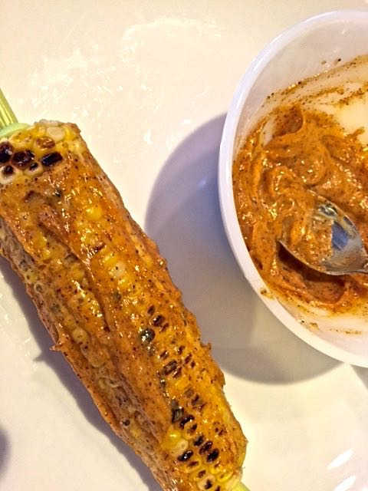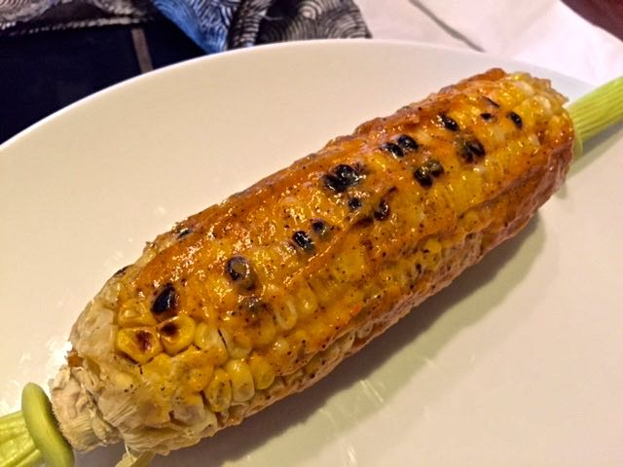

You’ll find this corn sold by street vendors on every corner in every Mexican town!

Ingredients:
2 ears sweet corn, husks/silk removed
1 tablespoon vegetable oil (see note)
4 tablespoons mayonnaise – use the real deal, not that “fat-free” crap with all the sugar in it
¼ teaspoon dark, Mexican chili powder
⅛ teaspoon granulated garlic powder
¼ teaspoon salt
Ground, black pepper, to taste
1 lime, quartered

Special Equipment: Grill pan (see note)

Preparation:
Preheat a grill pan. Rub corn with oil and place on the grill pan, turning corn so all sides are charred, about 6 to 10 minutes.

Meanwhile, mix together mayonnaise, chili powder, garlic powder, salt, and pepper.

Remove corn from grill and brush with the mayonnaise mixture. Serve with lime quarters to squeeze over corn.

Note:
If you’re using a non-stick grill pan, you don’t have to use the oil.

