Mexican Spaghetti (6 servings)

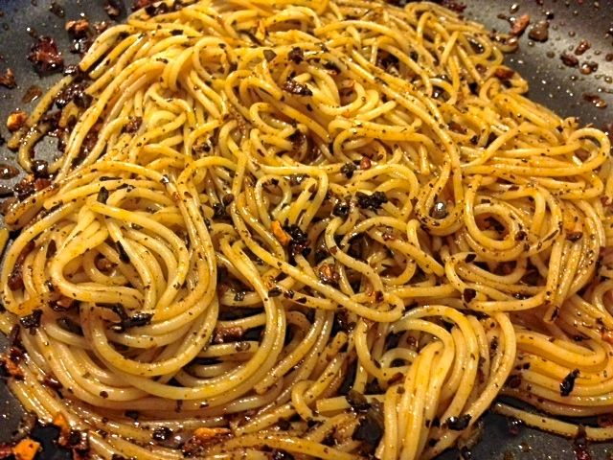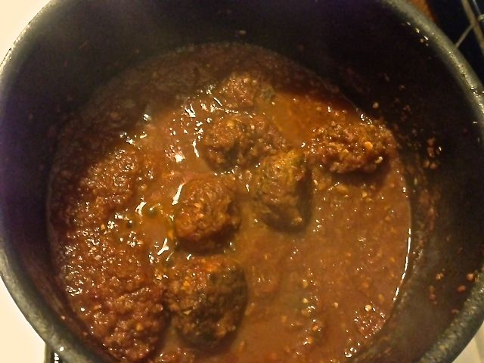

They love to eat all kinds of Italian pasta in Mexico!

Ingredients:
12 ounces thin spaghetti or vermicelli (4 ounces for two servings)
½ cup olive oil (¼ cup for two servings)
5 garlic cloves, minced (2 – 3 cloves for two servings)
1 teaspoon dried rosemary, crumbled (½ teaspoon for two)
1 teaspoon dried oregano, preferably the Mexican variety (½ teaspoon for two)
½ teaspoon dried thyme (¼ teaspoon for two)
½ teaspoon dried marjoram (¼ teaspoon for two)
5 guajillo chilies, stemmed, seeded and minced (2 large or 3 small for two)
Salt, to taste (I season everything as I go)
Ground, black pepper, to taste (I season everything as I go)
½ cup grated queso Cotija, queso Anejo, Parm or Pecorino (¼ cup for two servings)
2 tablespoons fresh parsley, coarsely chopped (optional, for garnish)

Preparation:
Bring salted water to a rolling boil. Add the pasta and let it come to a boil again. Boil, uncovered, until pasta is al dente, about 7 to 8 minutes. Scoop out 1 cup of the pasta cooking water and set aside. Drain the pasta.

In a large skillet or casserole, heat the olive oil over medium heat. Once it is hot, but not smoking, add the garlic and cook just until fragrant, 20 to 30 seconds, stirring continuously. Stir in the rosemary, oregano, thyme and marjoram, and cook for 30 to 40 seconds. Add the guajillo chilies and cook, continuing to stir, for another 20 to 30 seconds. You want them to gently brown, but not burn.

Add the pasta to the skillet and toss well. Pour in the reserved pasta water, toss and cook for another couple minutes. Remove from the heat. Taste and season with salt and pepper as needed. Serve garnished with freshly grated cheese and chopped parsley.

Serve with Mexican meatballs and bread with a nice, green salad on the side.

