Mexican Shredded Flank Steak with Potatoes in Green Salsa for Two (Carne Guisada en Salsa Verde con Papitas para Dos Personas)

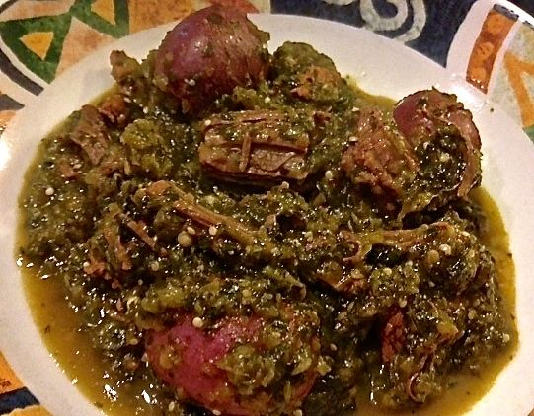 This guisado is what they really eat in Mexico!

Ingredients:
8 ounces flank steak, cut into 3” to 4” chunks
1 bay leaf
1 smaller white onion, cut in half – leave one half intact; peel & chop the other half
4 garlic cloves, peeled
½ teaspoon salt, plus ¼ teaspoon (divided)
5 black peppercorns
4 tomatillos, husks removed and rinsed
Jalapeño or serrano chilies with tops cut off, to taste (I like using 2 serrano chilies)
1 bunch fresh cilantro, leaves and top part of stems
1 tablespoon vegetable oil
¼ pound very small baby red potatoes (if not so small, halved or quartered bite size)

Preparation:
Place meat in a small saucepan along with the bay leaf, whole, unpeeled onion half, 3 garlic cloves, ½ teaspoon salt and the black peppercorns. Cover with water up to 2 inches above top of the meat. Bring to a boil over medium-high heat, reduce the heat to medium and simmer for about 1½ hours, covered, until the meat is thoroughly cooked and soft. Strain through a sieve over a large bowl, reserving only the broth and meat. Once the meat has cooled enough to handle, shred it into pieces.

While the meat simmers away, place the tomatillos, the remaining garlic clove and the chili in another small saucepan and cover with water. Bring to a simmer over medium heat, and cook until the tomatillos have changed their color from bright green to pale green and are soft and thoroughly cooked but not coming apart, about 10 minutes. Drain all and place in a large food processor. Add the chopped onion, cilantro and salt and puree until smooth. Taste for heat, adding more chilies or ground, red pepper or your favorite hot sauce until spicy enough for you.

Heat the oil in a small saucepan over medium heat (I clean out and reuse the one from the tomatillos). When the oil is hot, pour the salsa into the pot, along with the potatoes and cook, partially covered, until the sauce thickens slightly, about 5 to 6 minutes. Toss in the shredded meat and pour in a cup of the reserved meat broth. Stir and boil, partially covered, for 25 minutes, or until the potatoes are completely cooked through and soft and the stew has thickened considerably. Add more of the broth if the sauce is thickening too much. Garnish with a squeeze of limejuice.

