Mexican Scallop & Shrimp Cocktail (Cóctel) for Two

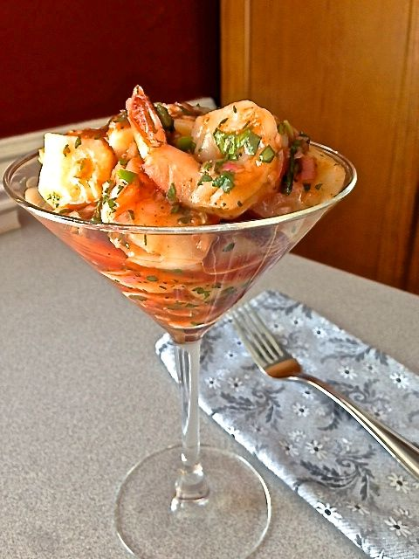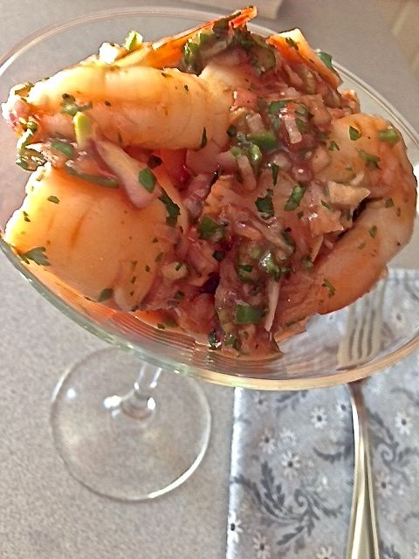

This is the best seafood cocktail ever!

Ingredients:
¼ pound (4 ounces) cooked small shrimp, peeled and deveined (I leave the tails on)
4 jumbo, dry-packed sea scallops
1 small shallot, finely chopped/minced
3 tablespoons clam-tomato juice (such as Clamato)
3 tablespoons ketchup
3 tablespoons fresh limejuice
4 teaspoons chopped fresh cilantro
1 very small serrano chili pepper, seeded and finely chopped
½ teaspoon hot sauce
Salt and ground, black pepper
Saltines, for serving

Preparation:
Bring a pot of salted water to a boil. Add the scallops, reduce the heat and poach gently for about 2 minutes. Drain and chill at least 30 minutes, or up to overnight.

Stir together the shallot, clam-tomato juice, ketchup, limejuice, cilantro, serrano chili and hot sauce in a medium bowl. Season with salt and pepper.

Pat the scallops dry with paper towels, then quarter them. Add the scallops and shrimp to the sauce and stir gently to combine. Chill well. Divide between 2 fancy glasses or favorite bowls. Serve with saltines, which is how they do it in Mexico.

