Mexican Sandwiches (Tortas) for Two

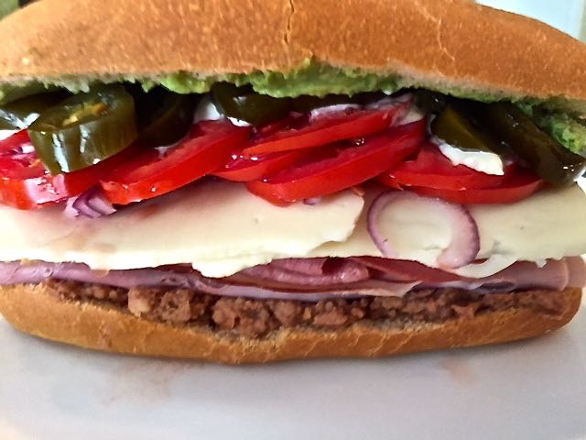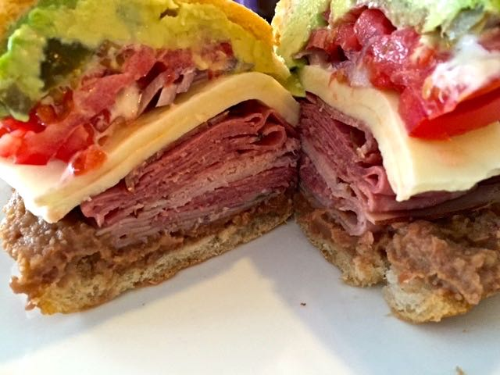

Ingredients:
2 Mexican bolillo or telera rolls, or small baguettes or ciabatta rolls
½ cup refried beans
½ ripe Mexican (Haas) avocado, scooped and sliced
A few slices Mexican queso fresco, Oaxaca or Mozzarella
A few deli-style slices of turkey, ham, any cold cuts or cooked, shredded chicken
1 tomato, sliced and seeded
A couple of thin slices of onion (optional)
Pickled jalapeño peppers, to taste (not optional)
Salt to taste
2 tablespoons Mexican-style cream, sour cream, crème fraîche or mayonnaise

Preparation:
Slice the rolls in half lengthwise. If they’re not fresh, toast them slightly for a few minutes. Scoop out the inside crumb from both halves so that they’re fairly hollow (I make breadcrumbs out of the scooped-out bread and keep them in the freezer). On one side, spread a tablespoon of refried beans; on the other, mash ¼ of an avocado with a fork.

Top the bottom half of the bread with slices of turkey or cold cuts of your choice (it may also be shredded chicken or meat), a few slices of cheese, then a couple thin slices of onion and thin tomato slices.

Drizzle a tablespoon of Mexican-style cream, sour cream, crème fraîche or mayonnaise and crown your package with as many pickled jalapeños as you wish. Sprinkle a bit of salt on top.

Place the top half of the roll on the sandwich and slice the torta horizontally. Eat it or wrap it up so that it can travel along with you.

