Mexican Roasted Holiday Pork Loin with Pineapple Glaze for Two

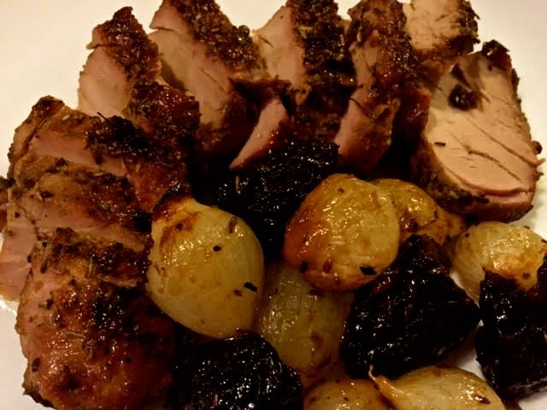

Ingredients:
½-pound pork tenderloin, cut in half
¼ cup salt (regular table salt, not kosher or flaked salt)
½ cup packed light brown sugar
1 tablespoon black peppercorns
1 tablespoon coriander seeds, slightly crushed between the palms of your hands
2 cups warm water
6 cups cold water
2 cloves garlic, minced
¾ teaspoon salt
¼ teaspoon ground, black pepper
1 teaspoon dried thyme leaves
1 teaspoon dried or fresh rosemary leaves
½ cup dried prunes, halved
10 ounces fresh pearl onions, peeled
⅓ cup dry white wine
1 cup pineapple juice
Olive oil
More salt and ground, black pepper, for general seasoning purposes (to taste)

Preparation:
Combine the ¼ cup salt, brown sugar, peppercorns, coriander seeds and 2 cups warm water in a large bowl (I use an 8-cup measuring cup). Stir until the salt dissolves. Add 6 cups cold water. Add the pork, cover, and refrigerate overnight (the pork should be submerged in the liquid – I do it in a glass baking dish covered with plastic wrap).

Preheat the oven to 400° F.

Make an herb rub by mixing together well the garlic, 1 tablespoon olive oil, ¾ teaspoon salt, the ¼ teaspoon pepper, thyme, and rosemary. Remove the pork from the brine and pat it dry (discard the brine). Spread the herb mixture over the pork loin, making sure you coat all sides of the loin.

Heat another tablespoon of olive oil in a medium sauté pan over medium-high heat. Add the pork and sear until browned, 4 minutes. Carefully turn the pork over and sear until browned, another 4 minutes. Meanwhile, add the prunes and pearl onions to a glass baking, creating a bed for the pork (I just wipe out and use the same dish the pork brined in overnight). Season the prunes and onions with salt and pepper.
Transfer the seared pork to the baking dish, insuring the pork fits, leaving a 1” border on every side.

Add the wine to the same sauté pan used to sear the pork and cook, scraping the bottom of the pan to remove the browned bits, until almost evaporated, about 1 minute. Stir in the pineapple juice and remove from the heat. Season with salt and pepper. Pour the mixture over the pork.

Place the pork in the oven and roast until a thermometer inserted into the center registers 160° F., about 1 hour, basting with the pan juices every 20 minutes (I suck the juices up from the bottom of the pan between the onions and prunes and squirt them all over the pork with a turkey baster). Transfer the pork to a cutting board, tent with foil, and let it stand for 10 minutes.

Slice the pork into ¼”- to ½”-thick slices to plate. Top the pork slices with the pearl onions, prunes, and sauce. Serve with a simple green salad and ranchero beans on the side.

