Mexican Red Rice with Giant Prawns for Two (Arroz Rojo con Camarones Gigantes)

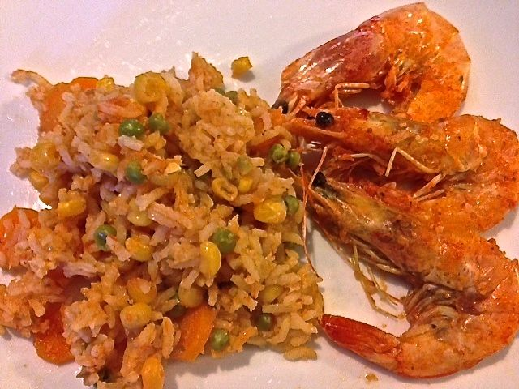

This is another recipe for the kind of thing that they really eat in Mexico.

Ingredients:
½ cup long- or extra-long-grain white rice or jasmine rice
1 medium-large, ripe tomatoes, quartered
2 ounces roughly chopped white onion (a really small one)
2 garlic cloves
½ teaspoon salt, or to taste
1 tablespoon vegetable oil
Chicken or vegetable broth (see recipe below for exact quantity)
1 small carrot, peeled and cut into thin rounds (optional)
¼ cup shelled green peas, fresh or frozen (optional)
¼ cup corn kernels, fresh or frozen (optional – I half a 7-ounce can of them)
1 jalapeño or serrano chili, roughly chopped (optional)
4 – 6 prawns with heads and shells intact, but deveined (Pacific Produce sells them on S. 27th St.)
Juice of half a lime (about 2 tablespoons)

Preparation:
Place rice in a bowl, cover with hot water, and soak for about 5 minutes. Strain and rinse under cold running water until the water runs clear; drain well. If you don’t have time to soak and drain the rice, you can skip this step.

In a blender or food processor, puree the tomatoes along with the onion, chili pepper (if using), garlic and salt until thoroughly smooth. Pass through a strainer into a measuring cup and reserve the puree solids. Add enough chicken broth to the strained liquid to make 1 cup of liquid total.

Heat the oil in a medium saucepan or casserole, over medium-high heat until hot but not smoking. Add the drained rice and cook, stirring often, until the rice becomes milky white and feels heavy in the pan as you stir, about 3 to 4 minutes. Pour in the strained tomato puree, mix gently and cook until the color of the puree darkens, thickens, and is mostly absorbed, about 3 to 4 more minutes. Stir in the pre-measured chicken broth and add the carrots, peas and corn (if using).

Bring to a boil, reduce heat, arrange the prawns on top, squeeze the limejuice all over, cover, and reduce heat to the lowest setting. Cook until most of the liquid has been absorbed, yet there is still some moisture in the pan, about 15 minutes. The rice should be cooked and tender; if not, but the liquid is totally absorbed, add a couple tablespoons of water, cover again, and to cook for a couple more minutes.

Remove from the heat and let the rice rest, covered, for at least 5 minutes before you fluff with a fork and serve (2 – 3 prawns per serving).

