Mexican Picnic Burritos for Two (Burritos de Machaca) – 2 per serving

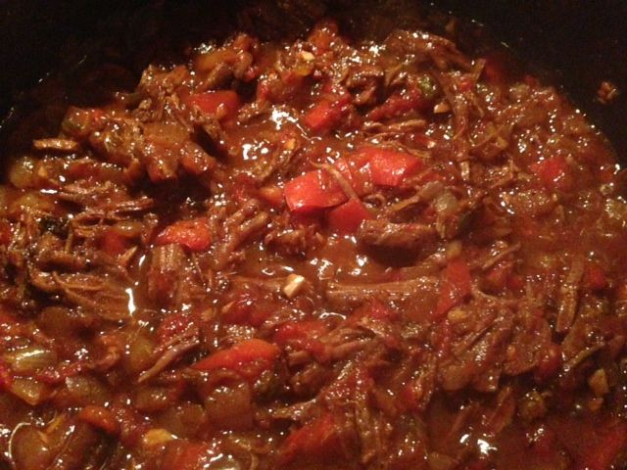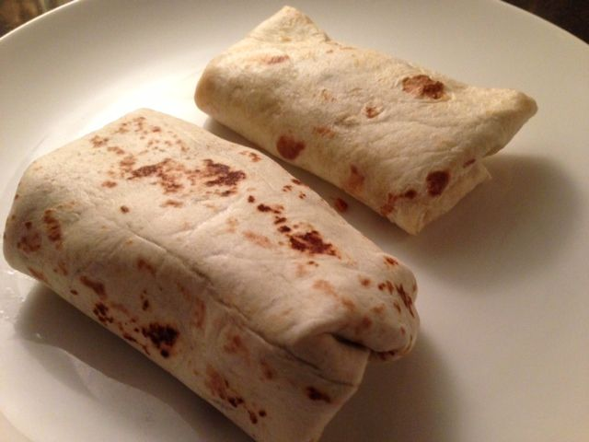

Ingredients: Marinade:
½ pound skirt steak, trimmed & cut into 2 pieces 1 tablespoon Maggi sauce*
½ teaspoon olive oil 1 tablespoon water
1 medium white onion, rough-chopped 2 tablespoons limejuice
1 medium red bell pepper, rough-chopped 2 garlic cloves, minced
2 cloves garlic, minced 1 Serrano chili, stemmed/minced
1 more Serrano chili, stemmed and minced ¼ cup olive oil
½ cup beef broth
1, 14-oz. can San Marzano tomatoes & juice, crushed by hand
¼ teaspoon dried oregano (preferably the Mexican variety!)
salt and freshly-ground black pepper
4, 6-inch flour tortillas

Directions:
Make the machaca marinade by combining the Maggi sauce, water, limejuice, garlic, chili, salt, and pepper, to taste, in a medium-size bowl. Slowly add the ¼ cup of olive oil, whisking constantly. Add the beef to the marinade and transfer to a quart-size freezer bag. Refrigerate for at least 8 hours or preferably overnight.

In a large saucepan, heat the ½ teaspoon olive oil over medium-high heat until just smoking. Sear the meat well on all sides (drain fat, if needed to brown). Set meat aside.

To the hot saucepan, add the onions, peppers, garlic, a little more olive oil and remaining chili. Season with a dash of salt & pepper. Sauté for 5 minutes, then add the broth, tomatoes, oregano and a little more salt and pepper. Mix well, then return the meat to the pot. Bring to a boil, reduce the heat, cover and simmer on low heat until the meat is very tender, about 2 hours. Transfer the meat to a cutting board and shred the meat into 2-inch-long strands. Return the shredded meat to the pot, stir to combine, and cook until meat is very hot and most of the liquid has evaporated.

Warm the tortillas over a burner or in a dry skillet over medium heat for 20 seconds. Put a quarter of the meat filling in a row through the center of each tortilla, and roll into a thin burrito by first closing up the short ends, then rolling up the rest in the classic burrito tube (practice makes perfect!). Wrap in aluminum foil to serve at picnics!

*You may substitute the Maggi sauce with 1½ teaspoons soy sauce mixed with 1½ teaspoons Worcestershire sauce.

