Mexican Beef & Vegetable Stew (Mole de Olla)

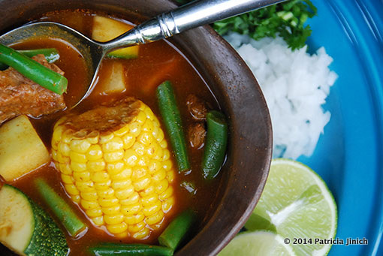

Although this stew is referred to as “mole” in Mexico, it’s not the kind of mole sauce with chocolate that we typically think of.

Ingredients:
3 pounds beef stew meat or beef shank meat cut into 1 1/2-inch to 2-inch chunks and bones added to the pot
½ white onion
3 bay leaves
3 cloves garlic
1 tablespoon kosher or coarse sea salt or to taste
10 cups water
1 large sprig of fresh mint or between 10 and 12 leaves
3 dried ancho chiles stemmed and seeded
3 dried pasilla chiles stemmed and seeded
1 pound (about 4) ripe tomatoes preferably Roma
¼ pound (about 1 or 2 depending on size) tomatillos – see note below
2 tablespoons sesame seeds lightly toasted
2 chayote squashes peeled and cubed (about 3 cups) – called “merlitons” down
1 large zucchini cubed (about 3 cups)
¾ pound green beans trimmed and cut into about 1-inch pieces (about 2 cups)
3 ears of fresh corn husked and cut into thirds
¾ cup finely chopped white onion for garnish
¾ cup Chopped fresh cilantro for garnish
3 – 4 limes quartered, for garnish

Preparation:
In a large heavy-bottomed casserole or pot, place the meat, half onion, garlic cloves, bay leaves, mint and a tablespoon of salt. Cover with 10 cups of water and bring to a rolling boil over medium-high heat. Skim off any foam that rises to the surface, and reduce the heat to low or medium-low heat, cover and simmer for an hour.

Meanwhile, place the ancho and pasilla chiles in a medium bowl, cover with boiling water and let them rehydrate for 10 to 15 minutes. Place the tomatoes and tomatillos in baking dish under the broiler, until they are completely charred and mushy, about 10 minutes. In a small skillet set over medium heat, place the sesame seeds and toast, stirring constantly, anywhere from 1 to 2 minutes until they start to become golden brown, but not completely dark brown.

In the jar of a blender, place the soaked chiles, along with ¼ cup of the soaking liquid, the broiled tomatoes and tomatillos, and the toasted sesame seeds, and puree until completely smooth.

Remove the lid from the large casserole, remove the cooked onion, mint and garlic cloves (if some remains, it is totally fine) and pour the chile mixture in with the meat. Stir, cover again and cook for another half hour.

Remove the lid, raise heat to medium heat, add the cubed chayote squash and the corn, and cook partially covered for 15 minutes. Add the green beans and zucchini, and cook partially covered for another 10 minutes. Taste for salt and add more if need be.

Serve in bowls, making sure that each bowl has a serving of meat, corn, chayote, green beans and zucchini. Place white onion, cilantro and halved limes at the table, for people to add as last seasonings and garnishes.

Note:
Traditionally, this recipe uses xoconostles, which are hard to find in the U.S. Instead, this recipe uses tomatillos, which have a similar tart flavor.

