Mexican Meatball Soup (Sopa de Albóndigas) for Two

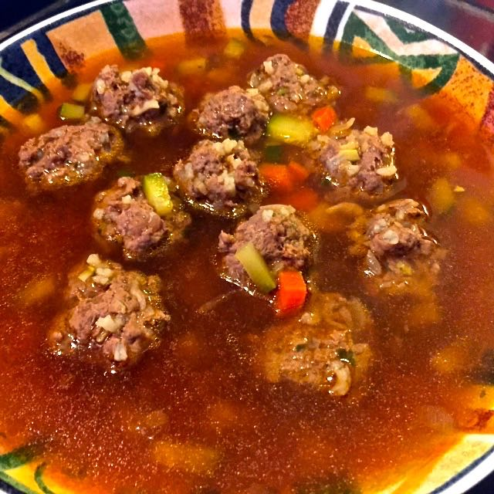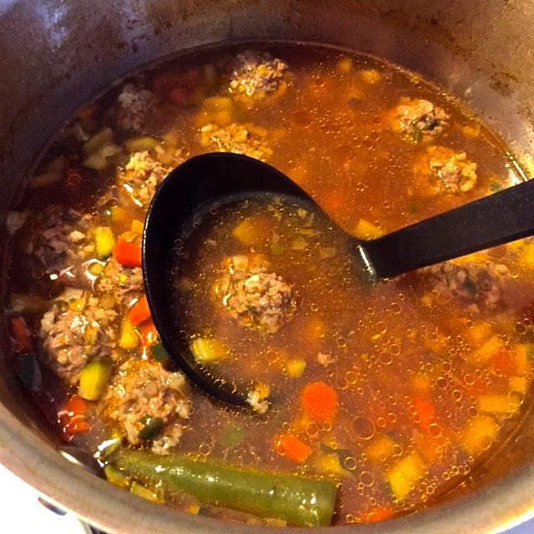

Ingredients:
½ pound (8 ounces) ground sirloin
1 small onion, minced (about ¼ cup)
4 cloves fresh garlic, peeled and minced
2 tablespoons, plus 2¼ teaspoons uncooked, long-grain rice
1 zucchini, finely diced (about ½ cup)
1 small carrot, peeled and finely chopped (about 6 tablespoons)
1 Serrano chili, whole with stem sliced off
1 small Yukon gold potato, skin on, finely diced (about ½ cup)
4 cups beef or vegetable stock
1 tablespoon chopped fresh cilantro
1½ teaspoons vegetable oil
1 tablespoon tomato paste
½ teaspoon each salt and ground, black pepper, or to taste

Preparation:
In a heavy large saucepan, heat the vegetable oil over medium-high heat. Add the onions and garlic; sauté only until translucent, about 5 minutes. Cool slightly.

In a medium bowl, mix together the sautéed onions and garlic, the rice, cilantro, ground meat, salt and pepper. Using wet hands (I wear washed latex gloves), shape the meat mixture into 22 to 23 meatballs about an inch in diameter each (just a little under a tablespoon of it for each).

Add the carrots, Serrano chili, potato, tomato paste, and stock into the saucepan and bring to a boil. Add the meatballs and zucchini, cover and simmer on low heat until the meatballs are cooked through, about 20 minutes.

Season the soup with more salt and pepper, to taste.

