Mexican Honey-Chipotle BBQ Ribs for Two (Costillitas con Chipotle y Miel para Dos)

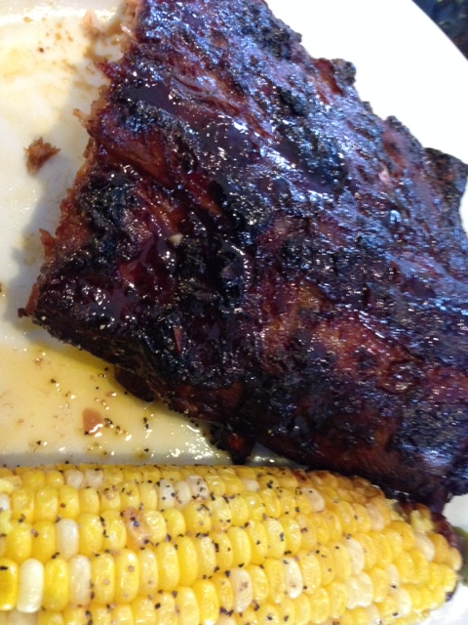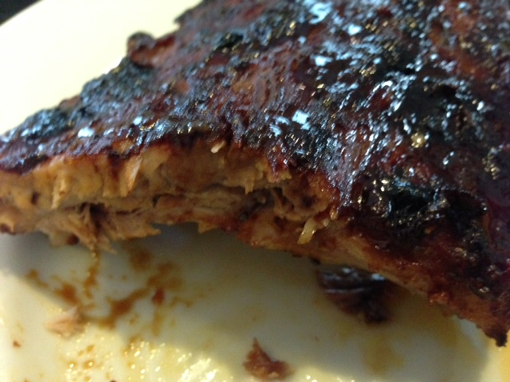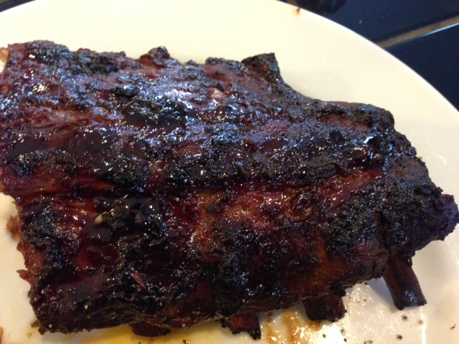

Ingredients:
1 rack pork “baby-back” spare ribs (one “rack” of pork loin back ribs cut in half serves two diners); make sure you get some with lots of thick meat on the top-side.
½ cup ketchup
⅓ cup honey
As much sauce from chipotles in adobo sauce as you can spoon out of the can
2 chipotle chilis from chipotles in adobo sauce, minced - optional, or more to taste
5 garlic cloves, pressed or minced
1 tablespoon olive oil
3 tablespoons Dijon mustard
3 tablespoons apple cider vinegar
1 tablespoon Worcestershire sauce
2 tablespoons Maggi or soy sauce
½ teaspoon ground, black pepper
1 tablespoon dried oregano, preferably the Mexican variety

Preparation:
In a medium bowl, combine the ketchup, honey, sauce from the chipotles, chipotle chilis, garlic, olive oil, Dijon mustard, apple cider vinegar, Worcestershire, Maggi/soy sauce, black pepper and oregano. Mix well.

Line a baking sheet with parchment paper or aluminum foil. Pour some sauce on the bottom of the pan, put in the ribs and pour the remaining sauce on top. Cover with foil, sealing the entire top of the pan, and marinate for 30 minutes up to 24 hours. If marinating more than 30 minutes, keep the ribs refrigerated.

When ready to cook the meat, remove it from the refrigerator. Preheat the oven to 350° F. Slip the pan with the ribs into the oven and roast for 1½ hours. Take the ribs from the oven and carefully remove the aluminum foil. Spoon the thickened sauce from the bottom of the pan on top of the ribs and place them back in the oven to roast another 20 to 30 minutes, or until they are beautifully browned and sticky. Remove from the oven, let rest, then slice into 2- to 3-bone pieces to serve.

Alternatively, after you remove the foil, you can finish off the ribs on the grill at medium heat, for about 15 minutes.

