Mexican Christmas Salad for Two (Ensalada de Navidad)

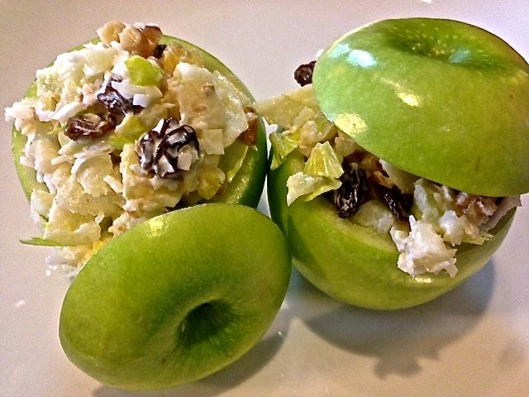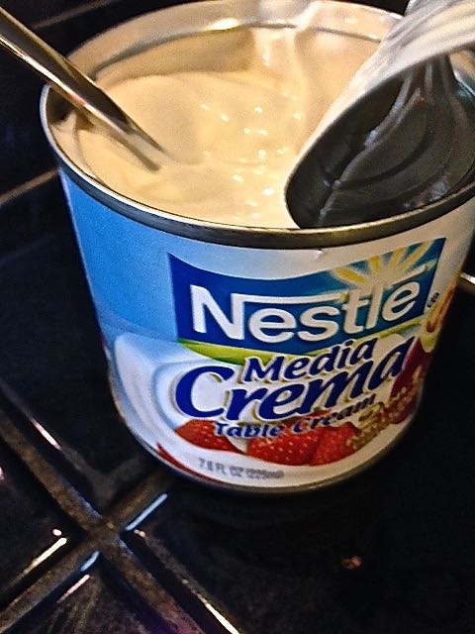

It’s traditional to serve pork tamales, clear-broth beef stew (pozole de res) and this Waldorfesque salad at Christmas time in Mexico.

Ingredients:
2 Granny Smith apples
2 tablespoons diced pineapple
2 tablespoons diced celery
2 tablespoons raisins (a 1-ounce box)
2 tablespoons sweetened, shredded coconut
2 tablespoons walnuts, roughly chopped
1 tablespoon mayonnaise
1 teaspoon thick Mexican crema, crème fraîche or sour cream
Salt and ground, black pepper, to taste

Preparation:
Slice ¼ of the top off of each apple and reserve (see note bellow). Using a teaspoon, scoop out the apple flesh to leave a hollow cavity in which to fill with the finished salad. Coarsely chop the apple flesh (discard the core and seeds) and mix with the remaining ingredients in medium bowl. Season with salt and pepper, to taste, and fold it together.

Spoon half of the mixture in each hollowed out apple and place the reserved tops on the filling. Pack it in well and heap it on top – believe me, it’ll all go (you may have a small bit left over). Serve cold or at room temperature.

Note:
To prevent the apples from turning brown while preparing the filling, rub the the interiors and the bottoms of the tops with the juice of a lime (about 2 tablespoons).

