Mexican Chilled Avocado Soup for Two

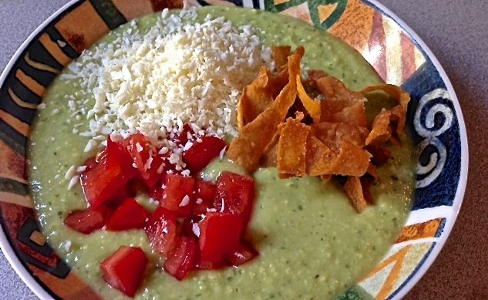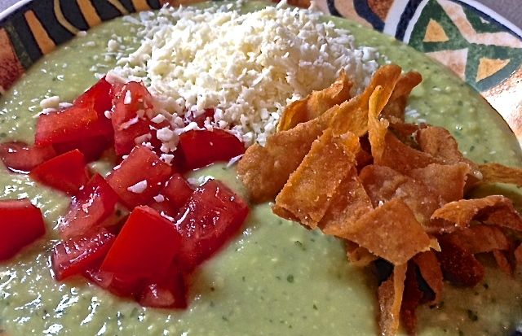

Ingredients:
1 tablespoon olive oil
½ cup rough-diced white onion (half a medium-small one)
1 small serrano chili, stemmed, seeded, and rough-chopped
1 garlic clove, rough-chopped or roughly sliced
Salt, for seasoning
1 firm, ripe avocado – see recipe for preparation
1 cup chicken broth
¼ lemon juice (the juice of half a medium-large lemon or 1 small lemon)
1 tablespoon fresh cilantro (a few sprigs, to taste)
½ cup water
¼ teaspoon freshly ground black pepper
4 corn tortillas, cut into strips 1” – 2” long and about ¼“ wide, for garnish (I use a pair of kitchen sheers to cut the tortillas in half, then I put them together in manageable stacks and use the sheers to cut them into narrow strips.)
Crumbled Mexican white cheese, to taste, and diced tomato, for garnish

Preparation:
Bring a small skillet to medium-low heat on the stove, then bring the olive oil to heat in it. Add the onion, chili and the garlic; sauté until slightly soft and barely colored. Season with salt, to taste. Remove from the heat and set aside to cool.

After the onion mixture has cooled, quickly slice the avocado in half, remove the pit and, using a large kitchen spoon, plop the avocado halves out of their skins into the bowl of a large food processor (do this quickly so that the avocado does not oxidize and get brown at all – after the lemon juice is added, it will stay bright green). Add the chicken broth, lemon juice, cilantro, cooled onion mixture and water. Puree until smooth, then put the puree into a bowl. Stir in the ¼ teaspoon of salt and the ¼ teaspoon of pepper, then cover and refrigerate until well chilled, about 3 hours.

While the soup chills in the fridge, prepare the tortilla strips to garnish the soup. Fill a small saucepan with a couple of inches of vegetable oil and bring it to 350° F. on a candy thermometer over medium-high heat. Fry the tortilla strips in very small batches until crispy and golden – I like to have some very dark brown, even burned, too, because they taste awesome. Season them with salt right as you take them out of the oil and drain on a paper towels

Pour chilled soup into individual bowls. Garnish each serving with 3 little piles of crumbled cheese, diced tomato and fried tortilla-chip strips (rajas de tortillas fritas).

