Mexican Chicken in Peanut Sauce for Two

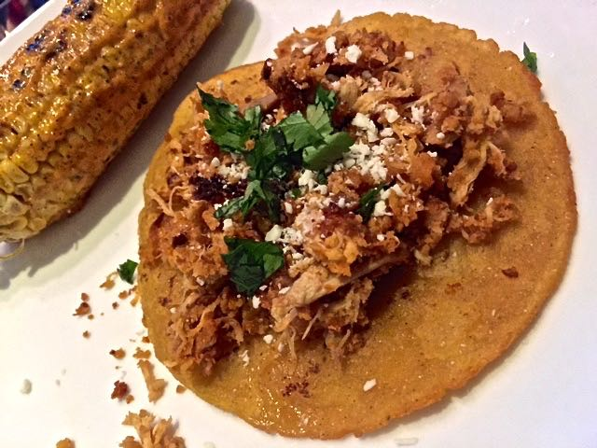

This is a versatile dish that can be served any number of ways. I like to stuff tomatoes with it, but it also makes a great tostada topping. You can fill tacos and burritos with it, or just serve with warm, corn tortillas and/or white rice on the side.

Ingredients:
8 – 12 ounces shredded, cooked chicken meat (I buy a smoked rotisserie chicken from Whole Foods and shred/debone half of it for this recipe)
1 large tomato
1 cup roasted, unsalted peanuts
3 tablespoons creamy peanut butter
1 – 2 chipotle chilies in adobo sauce (from canned chipotles)
Chopped fresh cilantro, for garnish
Fresh limejuice, for garnish
Salt and ground, black pepper, to taste

Preparation:
Bring a medium-sized saucepan of salted water to a boil. Add the tomato and cook for 3 minutes. Let cool. Peel, remove the stem-core and add to a large food processor. Process the tomato, peanuts, peanut butter and chipotle(s) until smooth. Season with salt and pepper.

Empty the water out of the saucepan and add in the sauce from the food processor and chicken. Stir over medium heat until warm. Sprinkle with a squeeze of fresh limejuice and chopped cilantro before serving. I also like to sprinkle a little grated Mexican white cheese and my favorite hot sauce over it.

