Mexican Beef Clear-Broth Soup (Pozole de Res) for Two

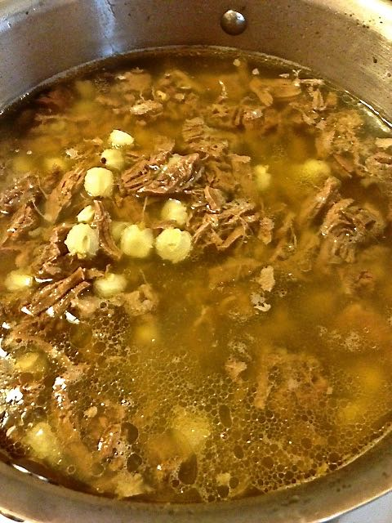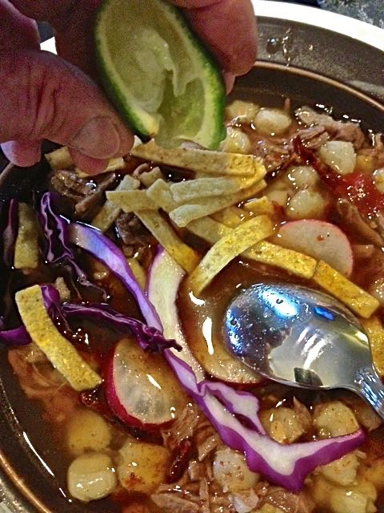

It’s traditional to serve this at Christmas time in Mexico.

Ingredients:
1¼ pounds beef shank
1 smaller white onion, unpeeled and quartered
1 medium-small carrot, unpeeled and roughly chopped
1 small stick celery, roughly chopped
1 clove garlic, unpeeled and crushed with the side of a chef’s knife
1 bay leaf
1 tablespoon salt, plus extra for seasoning
1½ teaspoons whole, black peppercorns
1, 24½-ounce can Mexican-style hominy, drained (oddly enough, the contents of the can will only weigh about 14 ounces) – NOT OPTIONAL
Ground black pepper
1½ cups thinly sliced cabbage, for garnish (optional)
½ cup thinly sliced radishes, for garnish (optional)
8 lime wedges (2 limes quartered), for garnish (optional)
4 teaspoons dried oregano, for garnish (optional)
Crispy-fried tortilla strips, for garnish (optional)

To make “Red” Pozole (Pozole Colorado) prepare the Pasilla-Guajillo Salsa recipe that follows (optional).

Preparation:
Place the beef shank in a large saucepan. Add enough cold water to cover the beef shank completely. Add the onion, carrot, celery, garlic clove, and bay leaf. Season with 1 tablespoon of salt and the peppercorns. Bring to a boil, cover, and reduce heat to a simmer. Cook until the meat is fully cooked and tender, about 2 hours. Be sure to continuously skim the foam from the surface of the liquid while cooking – it’s very important that the finished broth be as clear as possible.

Remove the meat from the pot and let cool. Strain the liquid and return to the pot. Add the hominy and bring to a boil. Lower the heat to a simmer. Season with salt and pepper, to taste.

Using a fork, shred the meat into thin pieces and return to the pot adding ½ cup of water, if necessary. Season with salt and pepper, to taste. Simmer for 5 minutes.

Serve hot, garnished with cabbage, radishes, lime wedges, dried oregano, tostadas, and Pasilla-Guajillo Salsa, if using.

Pasilla-Guajillo Salsa Ingredients:
2 pasilla chilis (dried poblanos), stemmed and seeded
2 guajillo chils, stemmed and seeded
2 cloves garlic, peeled and crushed with the side of a chef’s knife
Salt and ground, black pepper

Preparation:
Soak the seeded and stemmed chilis and garlic cloves in boiliong water to cover in a small bowl until the chilis are soft. Place the chilis, garlic, and their soak-water in a blender or small food processor and blend until smooth. Season with salt and pepper, to taste. Serve with Beef Pozole as a garnish.

