Mexican Beef Barbeque for Two (Barbacoa de Res)

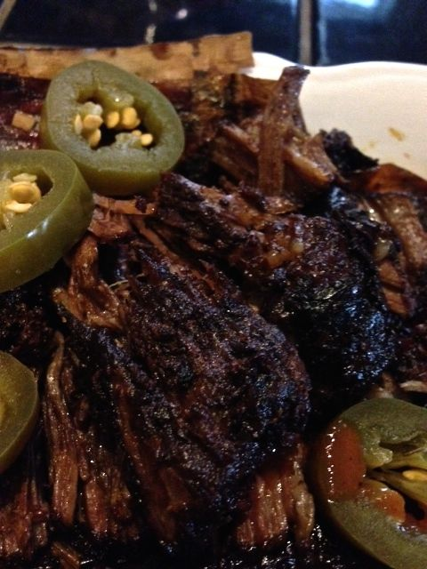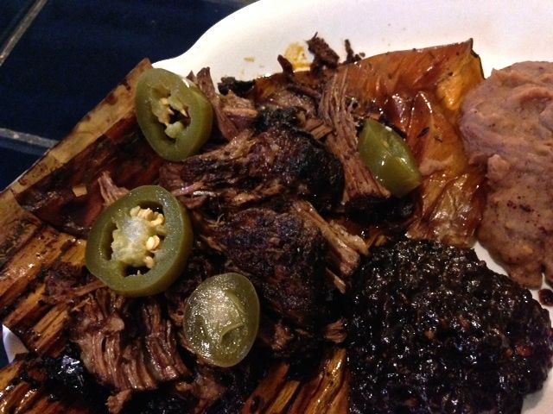

There are a lot of steps in this recipe, but it’s really easy and so very authentic.

Ingredients:
½ pound beef round roast or ¾ - 1 pound brisket (brisket really shrinks up a lot during the cooking process), cut into two, big 4” hunks
2 banana/plantain leaves, or aluminum foil – sold at Latin grocery stores
3 tablespoons light beer
2 – 4 Tortillas or small slider buns
Drunken pasilla, prune and orange salsa (optional, but GOOD – recipe follows)
Pickled jalapeños (optional)

For the Marinade
1 dried guajillo chili (long with smooth, tamarind-colored skin), stemmed/seeded
3 ancho chilis (wide with very dark, wrinkly skin), stemmed and seeded
1 cup water
2 teaspoons apple cider vinegar
1 small Roma tomato, quartered
1 small shallot or, preferably, about ½ - 1 ounce of white onion, coarsely chopped
1 small clove fresh garlic
½ teaspoon dried oregano, preferably the Mexican variety
⅛ teaspoon ground cinnamon
⅛ teaspoon ground allspice or whole allspice berries
⅛ teaspoon ground, black pepper
1 whole clove
½ teaspoon salt
1 teaspoon vegetable oil

Preparation:
Preheat the oven to 350°F.

For the marinade, heat a small saucepan over medium heat. Add the dried guajillo and ancho chilis and toast them well on each side (I like them to get smoking a little). Add the water and cook for 12 to 15 minutes, until the chilis have softened.

Transfer the chilis to a small food processor or blender, and add ¼ cup of their cooking liquid (discard the remaining liquid), the vinegar, tomato, onion, garlic, oregano, cinnamon, allspice, black pepper, cloves and salt. Puree until smooth.

Wipe out the saucepan and add the oil. Place over medium heat for 1 minute, then add the pureed chili mixture (careful – it’ll splatter!). Partially cover and cook for 5 - 6 minutes, stirring once or twice, until the color darkens and the mixture thickens to a paste-like consistency.

Place the meat in and cover it with the marinade. Wrap the individual meat chunks in the banana leaves or aluminum foil as you would wrap burritos or tamales - making sure to add a generous amount of marinade in each packet.

Place the meat packets inside a large, heavy ovenproof dish, pour in the beer and cover with a tight-fitting lid. Roast for about 3 hours, until the meat is succulent and comes apart when pulled with a fork. Transfer to the stovetop (off of the heat), and let everything rest for 10 to 15 minutes before opening the meat packets.

Make tacos out of the Barbacoa with warm tortillas or serve on slider buns with the drunken salsa and/or pickled jalapeños.

Drunken Pasilla, Prune & Orange Salsa (Salsa Borracha de Pasilla, Ciruela y Naranja) - Recipe makes about ¾ cup. It’s easy to make and deliciously authentic.

Ingredients:
1 - 2 pasilla or ancho chilis (about an ounce), stemmed and seeded
1 garlic clove, unpeeled
⅓ cup boiling water
⅓ cup light beer
Juice of 1 large orange
4 ounces pitted prunes (about 12 – 15 of them)
½ teaspoon salt

Preparation:
Set a small saucepan over medium heat and, once hot, toast the chilis for about 1 minute per side, being careful not to burn them. Remove from the saucepan.

Roast, or char, the garlic clove for about 6 to 8 minutes in the saucepan, or under a broiler for 3 to 4 minutes. Set aside and peel away the husk once the clove has cooled.

Place the toasted chilis back in the saucepan and cover with the boiling water, the beer and orange juice. Add the prunes to the saucepan and simmer for 8 to 10 minutes on low heat. Place the chilis, prunes and cooking liquid into a small food processor or blender, along with the garlic and salt. Puree until smooth. Serve warm with the Barbacoa.

