Mexican Ancho Chili Salsa Salad Dressing

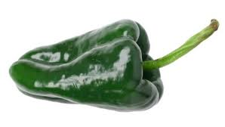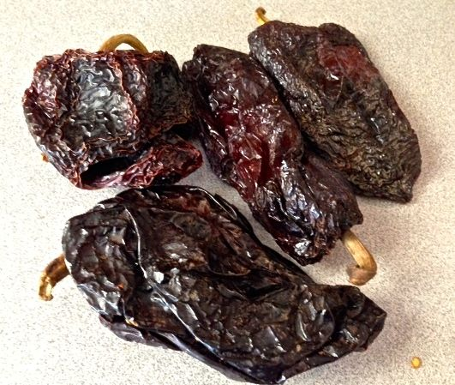

Ancho chilies are sold dried in U.S. markets. They’re very dark and wrinkly and have a bitter-sweet, almost chocolaty flavor to them. They are not spicy hot at all. This type of relish is called “salsa de tijeras” in Spanish – “tijeras” means scissors, which are used to cut the chilies into thin strips.

Ingredients:
2 ounces dried ancho chilies (about 4 medium-sized ones)
4 ounces white onion – a small one, chopped
1 clove fresh garlic, chopped
¼ cup rice vinegar
¼ cup white, distilled vinegar
¼ cup olive oil
2 teaspoons brown sugar
1½ teaspoons salt

Special Equipment: 1 quart-sized mason jar

Preparation:
Remove stems and seeds from the chilies and cut them into narrow, long strips with kitchen sheers. Place the chili strips into a large bowl as you go. In a quart-sized mason jar, shake together all the other ingredients. Pour the mixture over the chili strips and spoon it all together well, then spoon it all into the mason jar. Top with water so that the chilies are completely submerged.

Put the lid on the jar and shake it well. Marinate for at least 8 hours before using as a side-dish relish or for dressing salads.

