Estofado de Ternera o Res a la Madrilena (Madrid-style veal or beef stew with fried potato wedges and fried pepper strips)
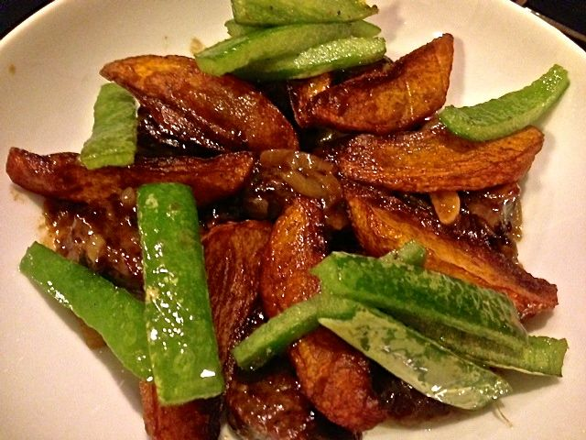

Ingredients:
1 small (about 2 - 4 ounces) yellow/Spanish onion, thinly sliced
2 cloves garlic, thinly sliced
½ pound veal or beef stew meat (I like using rump roast), cut into big, 1” – 2” chunks
3 tablespoons flour (approximately) for coating meat
2 tablespoons olive oil
1 bay leaf
10 whole black peppercorns
¼ teaspoon ground thyme
1 teaspoon parsley, minced
1 cup white wine
1½ teaspoons red wine vinegar
½ pound potatoes
1 sweet green pepper, cut into long, thin strips
1 cup olive oil for frying
Salt and ground, black pepper, to taste

Preparation:
Peel and slice onion and garlic into thin strips. Mince the parsley. Set aside.

Pour the 2 tablespoons flour, ½ teaspoon salt and ½ teaspoon pepper into a paper bag and mix together. Pour 2 tablespoons of olive oil into a large saucepan and heat on medium. Pat dry meat and shake it well with the seasoned flour in the bag.

When the oil is hot, brown meat on all sides, ensuring it has some nice color. Add the onion and garlic; sauté for 3 - 5 minutes. Add the rest of the ingredients, except potatoes and green pepper. Adjust salt to taste. Stir well, cover and simmer for 1½ - 2½ hours on low heat, until the meat is tender.

While the stew is cooking, peel the potatoes. Cut each potato in half lengthwise. Slice each half length-wise into 4 or more wedges. Salt the potatoes and toss to season evenly. Pour a cup or so of oil into a large, open frying pan. Oil should be about 1” deep in the pan. Heat the oil on medium high heat. Place all potatoes in the pan and fry until golden brown. Remove the potatoes with a slotted spoon or spatula and allow to drain on a paper towel.

Bring the heat of the oil back up to medium and the fry the pepper strips until soft. When the meat is tender, evenly divide the potatoes and peppers into 2 wide, shallow bowls and evenly ladle stew into the bowls. This dish goes nicely with a green salad served on the side. I like to serve it topped with the potatoes and pepper strips.

