Macarrones con Pollo - Puerto Rican Chicken & Pasta (recipe serves 2)

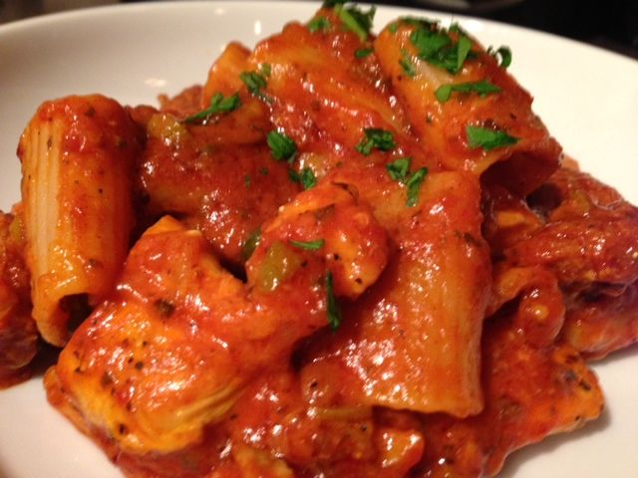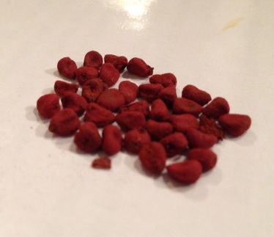
Ingredients:
¼ pound chicken pieces, seasoned with 2 teaspoons adobo (see note below)
¼ pound chorizo sausage, sliced, or smoked ham, diced
4 ounces rigatoni or large macaroni pasta
3 tablespoons olive oil and 1 tablespoon annatto/achiote (pronouncd “ah-chee-oh-tay”) seeds, available at Latin grocery markets
4 ounces zesty recaito (green, sold in Latin-American aisle of your grocery store)
¼ cup pimento-stuffed olives, chopped
1½ teaspoons capers
8 ounces Spanish-style tomato sauce
¼ teaspoon black pepper
⅓ cup Parmesan cheese, grated
Preparation:
Cook the pasta until it’s al dente and still just a tad bit chewy and undercooked.

Let 1 tablespoon annatto/achiote seeds steep in 3 tablespoons warming olive oil on medium heat in a medium (10” – 12”) skillet until it’s deep red, five minutes or so – keep an eye on it so it doesn’t burn!). Remove the seeds and discard them after the oil is nice and deep red. Brown the chicken and chorizo slices nicely in annatto/achiote oil. Add olives and capers; cook for 5 minutes. Add recaito, tomato sauce, pepper and pasta (and you can bet I also throw in some red-pepper flakes!). Bring to a boil, then reduce the heat to low and cook, covered, for 10 minutes. Add cheese. Heat through and toss well.

Notes:
Basic recaito: Blend in food processor:
½ medium yellow onion, diced
3 sweet chili peppers (ajicitos dulces), seeded and diced
3 sprigs cilantro, chopped
1 sprig culantro, chopped (or just use another sprig cilantro if unavailable)
2 tablespoons olive oil
2 cloves garlic, crushed
2 – 3 recao leaves (use @ 1 oz. fresh parsley if recao isn't available)

Adobo is just a mix of equal parts garlic powder, onion powder, salt, pepper and a pinch or two of dried oregano.

