Mexican Jalapeño-Roasted Chicken for Two

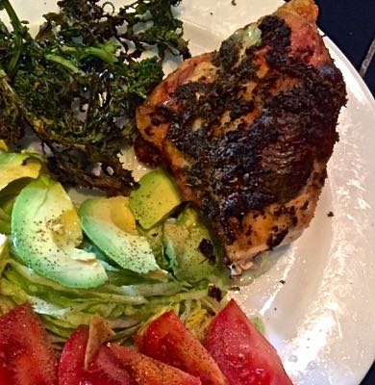

Serve this chicken with a simple, but traditional Mexican side salad made by topping shredded lettuce with avocado and tomato slices dressed with a squeeze of fresh lemon or lime juice and a sprinkling of salt and ground, black pepper.

Ingredients:
2 tablespoons plus 2¼ teaspoons dried oregano, preferably the Mexican variety
1 shallot, peeled and finely chopped
2 garlic cloves, peeled and smashed/crushed
2 tablespoons unsalted butter
1 tablespoon olive oil
1 jalapeño chili, stemmed, seeded and roughly chopped
½ teaspoon salt
¼ teaspoon ground black pepper
2 bone-in, skin-on chicken breasts (1 breast split into two pieces)
1 sprig fresh rosemary, cut in half
¾ cup chicken broth, plus more if needed
6 tablespoons dry white wine
1 pound broccoli, baby broccoli (a/k/a broccolini) or broccoli rabe
1½ teaspoons more olive oil
Salt and more ground black pepper

Special equipment: 1 roasting pan with rack.

Preparation:
Preheat the oven to 400° F.

Make a Jalapeño paste by combining the oregano, half the chopped shallot, garlic, butter, 1 tablespoon olive oil, the jalapeño, ½ teaspoon salt and ¼ teaspoon pepper (the first 8 ingredients) in the bowl of a food processor; process into a coarse paste.

Pat the chicken breasts dry and then put them, breast-side up, on a rack in a roasting pan. Using your fingers (I wear washed latex gloves), spread half of the jalapeño paste under and over the skin of each (gently form pockets under the skin). Put the rosemary and the other shallot under the skin. Pour the chicken broth and wine into the roasting pan.

Roast the chicken for 1 hour, basting with the pan juices every 20 minutes (I use a turkey baster), adding more broth to the pan if it begins to dry out.

Remove the roasting pan from the oven. Arrange the broccoli snugly around the chicken on the rack. Drizzle the olive oil over the florets and season them with salt and pepper, to taste. Roast the chicken with the broccoli, basting occasionally with the pan juices, until an instant-read thermometer inserted into the innermost part of the chicken thigh, without touching the bone, registers 160° F., about 10 – 15 minutes.

Remove the roast chicken from the oven, tent it in foil and let it rest for 15 minutes.

