Huevos Rancheros
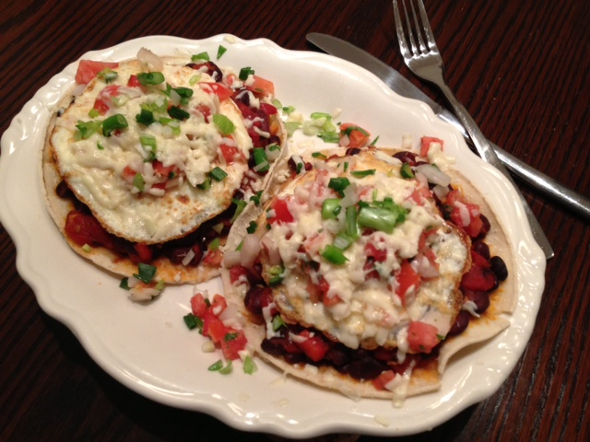
Ingredients:
2 tablespoons bacon grease, butter or vegetable oil
1 red-bell pepper
1 large tomato, seeded and chopped (I use a can of Italian San Marzanos, drained)
2 cloves garlic, minced
1, 15-ounce can black beans, drained/rinsed
1 tablespoon white-wine vinegar
Tabasco or other hot sauce, salt and ground, black pepper, to taste
2 tablespoons fresh cilantro, minced
2 corn tortillas
2 large eggs
A couple tablespoons salsa or pico de gallo
⅓ (a few ounces) fried, crumbled chorizo
¼ cup Mexican or other cheese, grated
1 green onion/scallion, both green and white parts, chopped

Preparation:
Roast the bell pepper directly over a gas flame or 4 inches below a very hot electric broiler, turning regularly until blistered and blackened all over, about 5 minutes for an open flame, about 10 minutes for the broiler. Place the blackened chili between dampened paper towels and allow to cool down a little so you can rub off the blackened skin, slice it open and scrape out all the seeds carefully with the back of a knife. DO NOT RINSE IT OFF! Chop the pepper.

Heat a tablespoon of fat in a 10-inch skillet over medium heat. Add in the chopped bell pepper, garlic and tomato. Sauté until the tomato softens, about 4 minutes. Add in the beans, hot sauce and vinegar. Cook until liquid is reduced at least 75%. Stir in the cilantro and season with a dash of salt and pepper.

Warm up the tortillas a minute or two until they’re softened in a skillet over medium heat or 15 seconds in the microwave, then lay them next to each other on a heat-proof serving plate (that can be safely placed under a broiler). Spoon half of the bean mixture evenly over each plated tortilla.

In a small skillet, heat the remaining tablespoon of fat. Fry the eggs in the skillet, keeping them as separated from one another as you can (I do them one at a time). Fry the eggs until the whites are fairly well set, then flip them over and cook until desired doneness (I prefer the yokes to remain a little runny!).

Place an egg on each plated tortilla with beans mixture. Top with fried, crumbled chorizo, salsa and/or pico de gallo and sprinkle each with grated cheese. Place under a hot broiler until the cheese melts nicely. Garnish with the chopped scallion and serve immediately.

